

Faculty of Computing & IT

University of Sialkot

TITLE

Session: MSC-IT Spring 2008-2012

Project Advisor: XYZ

Submitted By

XYZA | 1476147-0909
XYZB | 141561-0976

Faculty of Computing & IT
University of Sialkot

STATEMENT OF SUBMISSION

This is certify that _____________ Roll No. ____________ and _______________ Roll No. ______________ have successfully completed the final year project named as_____________ at the Department of Information Technology, University of Sialkot, to fulfill the requirement of the degree of _______ in Information Technology.

______________________ ______________________
Project Supervisor Project Management Office
Faculty of C&IT -USKT

______________________
Head of the Department

Acknowledgement

We truly acknowledge the cooperation and help make by ________________, Chairman, Department of Information Technology, University of Sialkot. He has been a constant source of guidance throughout the course of this project. We would also like to thank Mr. _____________________ for his help and guidance throughout this project. We are also thankful to our friends and families whose silent support led us to complete our project.

1- M. Aslam
2- M. Akram

Date: September 26, 2012

Abstract

Abstracts must include sufficient information for reviewers to judge the nature and significance of the topic, the adequacy of the investigative strategy, the nature of the results, and the conclusions. The abstract should summarize the substantive results of the work and not merely list topics to be discussed. An abstract is an outline/brief summary of your paper and your whole project. It should have an intro, body and conclusion. It is a well-developed paragraph, should be exact in wording, and must be understandable to a wide audience. Abstracts should be no more than 250 words, formatted in Microsoft Word, and single-spaced, using size 12 Times New Roman font. Abstracts highlight major points of your research and explain why your work is important; what your purpose was, how you went about your project, what you learned, and what you concluded.

Table of Contents
Chapter 1: Project Feasibility Report 8
1.1. Introduction 8
1.2. Problem Statement 9
1.3. Objectives 9
1.4. Project Motivation 9
1.5. Project/Product Feasibility Report 9
1.5.1. Technical Feasibility 9
1.5.2. Operational Feasibility 9
1.5.3. Economic Feasibility 10
1.5.4. Schedule Feasibility 10
1.5.5. Specification Feasibility 10
1.5.6. Market Analysis/Preliminary Record 10
1.5.7. Motivational Feasibility 10
1.5.8. Legal & Ethical Feasibility 10
1.6. Project/Product Scope 10
1.7. Project/Product Costing 11
1.7.1. Project Cost Estimation By Function Point Analysis 11
1.7.2. Project Cost Estimation by using COCOMO’81 (Constructive Cost Model) 13
1.7.3. Activity Based Costing 14
1.8. Task Dependency Table 15
1.9. CPM - Critical Path Method 15
1.10. Gantt chart 18
1.11. Introduction to Team member and their skill set 19
1.12. Task and Member Assignment Table 19
1.13. Tools and Technology with reasoning 22
1.14. Vision Document 23
1.15. Risk List 24
1.16. Product Features/ Product Decomposition 24
Chapter 2: Software Requirement Specification 25
2.1 Introduction: 26
2.1.1 Systems Specifications 27
2.1.2. Identifying External Entities 27
2.1.3. Context Level Data Flow Diagram: 28
2.1.4. Capture "shall" Statements: 28
2.1.5. Allocate Requirements: 28
2.1.6. Prioritize Requirements: 28
2.1.7. Requirements Trace-ability Matrix: 28
2.2. Example: 28
2.2.1. Introduction 28
2.2.2. Existing System 28
2.2.3. Scope of the System 29
2.2.4. Business Model 30
2.2.5. Summary of Requirements :( Initial Requirements) 30
2.2.6. Identifying External Entities: 32
2.2.7. Capture "shall" Statements: 32
2.2.8. Allocate Requirements: 33
2.2.9. Priorities Requirements: 35
2.2.10. Requirements Traceability Matrix: 38
2.2.11. High Level Use case Diagram: 40
2.2.12. Analysis Level Usecase Diagram: 42
2.2.13. Usecase Description 42
Chapter 3: Software Architecture and Design 44
3.1. Introduction: 45
3.2. Domain Model 45
3.3. Architecture/Design Pattern 46
3.4. Algorithm Flow Chart 47
3.5 System Sequence Diagram 48
3.6. Sequence Diagram 49
3.6.1. Defining a Sequence diagram 49
3.6.2. Basic Sequence Diagram Symbols and Notations 49
3.6.3. Example 53
3.6.4. Distributing Control Flow in Sequence Diagrams 53
3.7. Collaboration Diagram 56
3.7.1. Contents of Collaboration Diagrams 57
3.7.2. Constructs of Collaboration Diagram: 57
3.8. Operation Contracts 58
3.9. Design Class Diagram 59
3.9.1. Create Initial Design Classes 59
3.9.2. Designing Boundary Classes 60
3.9.3. Designing Entity Classes 60
3.9.4. Designing Control Classes 60
3.9.5. Identify Persistent Classes 61
3.9.6. Define Class Visibility 62
3.9.7. Design Class Relationships 66
3.10. State chart diagram 70
3.11. Database Model 71
Chapter 4: User Interface Design 76
4.1. Introduction 77
4.2. Site Maps 77
4.3. Story boards 78
4.4. Prototype 79
4.5. Product Interfaces 80
4.6. Navigational maps: 80
4.7. Trace-ability Matrix 81
Chapter 5: Software Testing 82
5.1 Introduction: 83
5.2. Black box plan/White box plan/Grey box plan 83
5.3. Test plan 86
5.3.1. Purpose 86
5.3.2. Outline 86
5.4. Test design specification 89
5.4.1. Purpose 89
5.4.2. Outline 89
5.5. Test Case Specification 93
5.5.1. Purpose 93
5.5.2. Outline 93
5.6. Test procedure specification 95
5.6.1. Purpose 95
5.6.2 Outline 95
5.7. Test item transmittal report 96
5.7.1. Purpose 96
5.7.2. Outline 96
5.8. Test log 97
5.8.1. Purpose 97
5.8.2. Outline 97
5.9. Test incident report 99
5.9.1. Purpose 99
5.9.2. Outline 99
5.10. Test summary report 100
5.10.1. Purpose 100
5.10.2. Outline 100
Chapter 6: Conclusion And Future Work 102
Appendixes: 112
Appendix 1: Final Documentation Format Guidelines 113

Chapter 1: Project Feasibility Report

Introduction
The introduction is the initial paragraph that begins the subsequent process of the project. Each project, each essay, or any article if it is written, receives an introductory paragraph that opens the way to successive paragraphs or topics of the project.

Problem Statement
A problem statement is a concise description of an issue to be addressed or a condition to be improved upon. It identifies the gap between the current (problem) state and desired (goal) state of a process or product.

Objectives
Project objectives are what you plan to achieve by the end of your project. This might include deliverables and assets, or more intangible objectives like increasing productivity or motivation. Your project objectives should be attainable, time-bound, specific goals you can measure at the end of your project.

Project Motivation
Motivation can inspire, encourage, and stimulate individuals and project teams to achieve great accomplishments. Motivation can also create an environment that fosters teamwork and collective initiatives to reach common goals or objectives.

1.5. Project/Product Feasibility Report
When a project is started, the first matter to establish is to assess the feasibility of a project or product. Feasibility means the extent to which appropriate data and information are readily available or can be obtained with available resources such as staff, expertise, time, and equipment. It is used as a measure of how practical or beneficial the development of a software system will be to you (or organization). This activity recurs throughout the life cycle.
There are many types of feasibilities:

- Technical
- Operational
- Economic
- Schedule
- Specification
- Information
- Motivational
- Legal and Ethical

1.5.1. Technical Feasibility
Technical Feasibility deals with asking the question as to whether the system can be developed or not. It is one of the most important questions before starting the project because it is assessing the limits of theory or technology applicable to the project. Another important query to be answered is to evaluate whether you (the project members or organization) possess the technology and technical expertise.

1.5.2. Operational Feasibility
Evaluation of technical ability of the staff to operate the project is the main aim of operational feasibility. In this area the question arises as to whether the problem is worth solving and if the solution provided for the problem works or not. How do end users and managers feel about the problem or solution is another query to be answered.

1.5.3. Economic Feasibility
Justification for the benefit/cost analysis relative to the project is to be measured in economic feasibility. Therefore, economic feasibility can be divided into two parts; cost estimates and benefit estimates. Cost estimates can further be alienated into development or acquisition costs (one time) and maintenance and operation costs (ongoing). In order to find development costs, break the project into tasks and use the lifecycle cost models. Experienced costs gained from similar projects should then be used to make estimates. The function point metric should be calculated.
Benefit estimates enclose tangible benefits and intangible benefits. Tangible benefits would include reduced costs and increased revenues. However, information quality, job satisfaction, and external standing are examples of intangible benefits.

1.5.4. Schedule Feasibility
Time is an important factor. The assessment and evaluation of the completion of a project with the available staff and resources within time is very essential. Meeting deadlines and milestones should always be kept in mind.

1.5.5. Specification Feasibility
Requirements are the features that the system must have or a constraint that must be accepted for the customer. The question arises as to whether the requirements are clear and definite. The scope boundaries must also be assessed.

1.5.6. Market Analysis/Preliminary Record
A market analysis is a quantitative and qualitative assessment of a market. It looks into the size of the market both in volume and in value, the various customer segments and buying patterns, the competition, and the economic environment in terms of barriers to entry and regulation.

1.5.7. Motivational Feasibility
Evaluation of the client staff regarding the motivation to perform the necessary steps correctly and promptly must occur.

1.5.8. Legal & Ethical Feasibility
”Do any infringements or liabilities arise from this project? “ is the main focus of this feasibility.

1.6. Project/Product Scope
Scope is a very dominant factor. Scope and context are both intertwined as both involve the boundaries of a system. Context would be referring to what holds outside the boundary the system. While scope would indicate whatever is inside the boundary of the system.
The scope of a project is defined by the set of requirements allocated to it. Managing project scope to fit the available resources (time, people, and money) is key to managing successful projects. Managing scope is a continuous activity that requires iterative or incremental development, which breaks project scope into smaller more manageable pieces.
Using requirement attributes, such as priority, effort, and risk, as the basis for negotiating the inclusion of a requirement is a particularly useful technique for managing scope. Focusing on the attributes rather than the requirements themselves helps desensitize negotiations that are otherwise contentious.

1.7. Project/Product Costing
A metric is some measurement we can make of a product or process in the overall development process. Metrics are split into two broad categories:
- Knowledge oriented metrics: these are oriented to tracking the process to evaluate, predict or monitor some part of the process.
- Achievement oriented metrics: these are often oriented to measuring some product aspect, often related to some overall measure of quality of the product.
Most of the work in the cost estimation field has focused on algorithmic cost modeling. In this process costs are analyzed using mathematical formulas linking costs or inputs with metrics to produce an estimated output. The formulae used in a formal model arise from the analysis of historical data. The accuracy of the model can be improved by calibrating the model to your specific development environment, which basically involves adjusting the weightings of the metrics.

1.7.1. Project Cost Estimation By Function Point Analysis
Function-oriented software metrics use a measure of the functionality delivered by the application as a normalization value. Since ‘functionality’ cannot be measured directly, it must be derived indirectly using other direct measures. Function-oriented metrics were first proposed by Albrecht, who suggested a measure called the function point. Function points are derived using an empirical relationship based on countable (direct) measures of software’s information domain and assessments of software complexity.
Function Point Analysis can provide a mechanism to track and monitor scope creep. Function Point counts at the end of requirements; analysis, design, code, testing and implementation can be compared. The function point count at the end of requirements and/or designs can be compared to function points actually delivered. If the project has grown, there has been scope creep. The amount of growth is an indication of how well requirements were gathered by and/or communicated to the project team. If the amount of growth of projects declines over time it is a natural assumption that communication with the user has improved.
Function points are computed by completing the table shown in the figure below. Five information domain characteristics are determined and counts are provided in the appropriate table location.
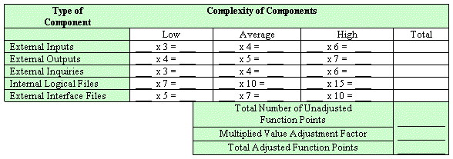

Information domain values are defined in the following manner:

Number of user inputs: Each user input that provides distinct application-oriented data to the software is counted. Inputs should be distinguished from inquiries, which are counted separately.

Number of user outputs: Each user output that provides application-oriented information to the user is counted. In this context output refers to reports, screens, error messages, etc. Individual data items within a report are not counted separately.

Number of user inquiries: An inquiry is defined ass an on-line input that results in the generation of some immediate software response in the form of an on-line output. Each distinct inquiry is counted.

Number of files: Each logical master file (i.e. a logical grouping of data that may be one part of a large database or a separate file) is counted.

Number of external interfaces: All the machine-readable interfaces (e.g., data files on storage media) that are used to transmit information to another system are counted.

Once these data have been collected, a complexity value is associated with each count. Organizations that use function point methods develop criteria for determining whether a particular entry is simple, average, or complex. Nonetheless, the determination of complexity is somewhat subjective.

To compute function points (FP), the following relationship is used:

FP est. = Count Total * [ 0.65 + 0.01 * (Fi)]

Where count total is the sum of all FP entries obtained from above figure and (Fi) is value adjustment factor (VAF) is based on 14 general system characteristics (GSC's) that rate the general functionality of the application being counted. Each characteristic has associated descriptions that help determine the degrees of influence of the characteristics. The degrees of influence range on a scale of zero to five, from no influence to strong influence.

1. Data communications
2. Distributed data processing
3. Performance
4. Heavily used configuration
5. Transaction rate
6. On-Line data entry
7. End-user efficiency
8. On-Line update
9. Complex processing
10. Reusability
11. Installation ease
12. Operational ease
13. Multiple sites
14. Facilitate change

Finally, Total Project Cost and Total Project Effort are calculated given the average productivity parameter for the system.

The formulae are given as follows:

Cost / FP = labor rate / productivity parameter

Total Project Cost = FP est. * (cost / FP)

Total Estimated Effort = FP est. / productivity parameter

1.7.2. Project Cost Estimation by using COCOMO’81 (Constructive Cost Model)
Boehm's COCOMO model is one of the mostly used models commercially. The first version of the model delivered in 1981 and COCOMO II is available now. COCOMO 81 is a model that allows one to estimate the cost, effort, and schedule when planning a new software development activity, according to software development practices that were commonly used in the 1970s through the 1980s. It exists in three forms, each one offering greater detail and accuracy the further along one is in the project planning and design process. Listed by increasing fidelity, these forms are called Basic, Intermediate, and Detailed COCOMO. However, only the Intermediate form has been implemented by USC in a calibrated software tool.
Three levels:

Basic: Is used mostly for rough, early estimates.
Intermediate: Is the most commonly used version, includes 15 different factors to account for the influence of various project attributes such as personnel capability, use of modern tools, hardware constraints, and so forth.
Detailed: Accounts for the influence of the different factors on individual project phases: design, coding/testing, and integration/testing. Detailed COCOMO is not used very often.

Each level includes three software development types:
- Organic: Relatively small software teams develop familiar types of software in an in-house environment. Most of the personnel have experience working with related systems.
- Embedded: The project may require new technology, unfamiliar algorithms, or an innovative new method
- Semi-detached: Is an intermediate stage between organic and embedded types.

Basic COCOMO
Type Effort Schedule
Organic PM= 2.4 (KLOC)1.05 TD= 2.5(PM)0.38
Semi-Detached PM= 3.0 (KLOC)1.12 TD= 2.5(PM)0.35
Embedded PM= 2.4 (KLOC)1.20 TD= 2.5(PM)0.32

PM= person-month (effort)
KLOC= lines of code, in thousands
TD= number of months estimated for software development (duration)

Intermediate COCOMO
Type Effort
Organic PM= 2.4 (KLOC)1.05 x M
Semi-Detached PM= 3.0 (KLOC)1.12 x M
Embedded PM= 2.4 (KLOC)1.20 x M

PM= person-month
KLOC= lines of code, in thousands
M.- reflects 15 predictor variables, called cost drivers

The schedule is determined using the Basic COCOMO schedule equations.

People Required = Effort / Duration

1.7.3. Activity Based Costing
Activity-based costing (ABC) is a methodology that measures the cost and performance of activities, resources, and cost objects. Resources are assigned to activities, then activities are assigned to cost objects based on their use. Activity-based costing recognizes the causal relationships of cost drivers to activities.
Activity-based costing is about:
- Measuring business process performance, activity by activity.
- Estimating the cost of business process outputs based on the cost of the resources used in producing the product.
- Identifying opportunities to improve process efficiency and effectiveness.
Activity costs are used as the quantitative measurement. If activities have unusually high costs or vice versa, they become targets for re-engineering.
Activity-based management (ABM) is a broad discipline

Basic Cost Drivers:
For each activity state in an activity diagram, the basic cost drivers are:
- Resources: determine what business workers and business entities are participating, and how many instances of each. The allocation of a resource to a workflow implies a certain cost.
- Cost rate: each business worker or business entity instance may have a cost per time in use.
- Duration: an activity occurs for a certain time, therefore a resource can either be allocated for the duration of the activity, or for a fixed amount of time.
- Overhead: any fixed costs that the invocation of a workflow or an activity would incur.

1.8. Task Dependency Table
The following are the steps to develop a task dependency table:
1. Brainstorm for all of the tasks necessary to complete your project, or take the output from a Tree Diagram that you have already produced.

2. Write each task on a Post-It Note or job card.

3. Establish which task is the first one that must be carried out and place its card on the left hand side of a large work surface.

4. Determine whether there are any tasks that can be done at the same time, i.e. tasks that are not dependent on this first task finishing before they can be carried out. If there are, place their job cards vertically above or below the first job card.

5. Then decide which is the next task that must be carried out and place its card on the right of the first card. Determine whether there are any tasks that can be done at the same time as this task. If there are, place their job cards vertically above or below its job card.

6. Repeat the process until all of the job cards have been arranged in sequence and in parallel.

1.9. CPM - Critical Path Method
In 1957, DuPont developed a project management method designed to address the challenge of shutting down chemical plants for maintenance and then restarting the plants once the maintenance had been completed. Given the complexity of the process, they developed the Critical Path Method (CPM) for managing such projects.
CPM provides the following benefits:

- Provides a graphical view of the project.
- Predicts the time required to complete the project.
- Shows which activities are critical to maintaining the schedule and which are not.

CPM models the activities and events of a project as a network. Activities are depicted as nodes on the network and events that signify the beginning or ending of activities are depicted as arcs or lines between the nodes. The following is an example of a CPM network diagram:
Steps in CPM Project Planning

1. Specify the individual activities.
2. Determine the sequence of those activities.
3. Draw a network diagram.
4. Estimate the completion time for each activity.
5. Identify the critical path (longest path through the network)
6. Update the CPM diagram as the project progresses.
1. Specify the Individual Activities
From the work breakdown structure, a listing can be made of all the activities in the project. This listing can be used as the basis for adding sequence and duration information in later steps.

2. Determine the Sequence of the Activities
Some activities are dependent on the completion of others. A listing of the immediate predecessors of each activity is useful for constructing the CPM network diagram.

3. Draw the Network Diagram
Once the activities and their sequencing have been defined, the CPM diagram can be drawn. CPM originally was developed as an activity on node (AON) network, but some project planners prefer to specify the activities on the arcs.

4. Estimate Activity Completion Time
The time required to complete each activity can be estimated using past experience or the estimates of knowledgeable persons. CPM is a deterministic model that does not take into account variation in the completion time, so only one number is used for an activity's time estimate.

5. Identify the Critical Path
The critical path is the longest-duration path through the network. The significance of the critical path is that the activities that lie on it cannot be delayed without delaying the project. Because of its impact on the entire project, critical path analysis is an important aspect of project planning.

Determining the following six parameters for each activity which can identify the critical path:

ES: earliest start time: the earliest time at which the activity can start given that its precedent activities must be completed first.
ES (K)= max [EF(J) : J is an immediate predecessor of K]

EF: earliest finish time: equal to the earliest start time for the activity plus the time required to complete the activity.
EF (K)= ES (K) + Dur (K)

LF: latest finish time: the latest time at which the activity can be completed without delaying the project.
LF (K)= min [LS(J) : J is a successor of K]

LS: latest start time: equal to the latest finish time minus the time required to complete the activity.
LS (K)= LF(K) – Dur (K)

TS: Total Slack: the time that the completion of an activity can be delayed without delaying the end of the project
TS (K)= LS(K) – ES(K)

FS: Free Slack: the time that an activity can be delayed without delaying both the start of any succeeding activity and the end of the project.
FS (K)= min [ES(J) : J is successor of K] – EF(K)

The slack time for an activity is the time between its earliest and latest start time, or between its earliest and latest finish time. Slack is the amount of time that an activity can be delayed past its earliest start or earliest finish without delaying the project.
The critical path is the path through the project network in which none of the activities have slack, that is, the path for which ES=LS and EF=LF for all activities in the path. A delay in the critical path delays the project. Similarly, to accelerate the project it is necessary to reduce the total time required for the activities in the critical path.

6. Update CPM Diagram
As the project progresses, the actual task completion times will be known and the network diagram can be updated to include this information. A new critical path may emerge, and structural changes may be made in the network if project requirements change.

Example:

Activity | Immediate Predecessor | Duration (Weeks)
A | None | 5
B | None | 3
C | A | 8
D | A, B | 7
E | None | 7
F | C, D, E | 4
G | F | 5

D
E
B
A
C
F
G
End
Start

Network Diagram for the above-mentioned activities

Activity | Duration | ES | EF | LS | LF | TS | FS
A | 5 | 0 | 5 | 0 | 5 | 0 | 0
B | 3 | 0 | 3 | 3 | 6 | 3 | 2
C | 8 | 5 | 13 | 5 | 13 | 0 | 0
D | 7 | 5 | 12 | 6 | 13 | 1 | 1
E | 7 | 0 | 7 | 6 | 13 | 6 | 6
F | 4 | 13 | 17 | 13 | 17 | 0 | 0
G | 5 | 17 | 22 | 17 | 13 | 0 | 0

The parameters and slacks are calculated as follows:

The critical path is:
A, C, F, G

1.10. Gantt chart
The Gantt chart enumerates the activities to be performed on the vertical axis and their corresponding duration on the horizontal axis. It is possible to schedule activities by either early start or late start logic. In the early start approach, each activity is initiated as early as possible without violating the precedence relations. In the late start approach, each activity is delayed as much as possible as long as the earliest finish time of the project is not compromised.
Based on the Work Breakdown Structure (WBS), a timeline or Gantt chart showing the allocation of time to the project phases or iterations should be developed. This Gantt chart would identify major milestones with their achievement criteria. It must contain duration estimation of all the necessary activities to be carried out during the project development along with the human resources responsible for the respective tasks. Activity dependencies are also required to be mentioned in it.

1.11. Introduction to Team member and their skill set
A brief but a concise introduction of the team members should be provided signifying their skill set. This skill set would especially be representative of the tasks and activities assigned to him.

1.12. Task and Member Assignment Table
A table should be formed which consists of a list of tasks and correspondingly allocation of members to that task. The basic aim of this table would be an indication of the amount of work the members would be performing.

Example for Task Durations and Dependencies, Activity Network Diagram, Gantt chart, and Allocation of People to Activities

Task | Duration (days) | Dependencies
T1 | 8
T2 | 15
T3 | 15 | T1(M1)
T4 | 10
T5 | 10 | T2, T4(M2)
T6 | 5 | T1, T2 (M3)
T7 | 20 | T1 (M1)
T8 | 25 | T4 (M5)
T9 | 15 | T3, T6 (M4)
T10 | 15 | T5, T7 (M7)
T11 | 7 | T9 (M6)
T12 | 10 | T11 (M8)

Consider the set of activities shown in figure. This table shows activities, their duration, and activity interdependencies. From figure, you can see that Task T3 is dependent on Task T1. This means that T1 must be completed before T3 starts. For example, T1 might be the preparation of a component design and T3, the implementation of that design. Before implementation starts, the design should be complete.

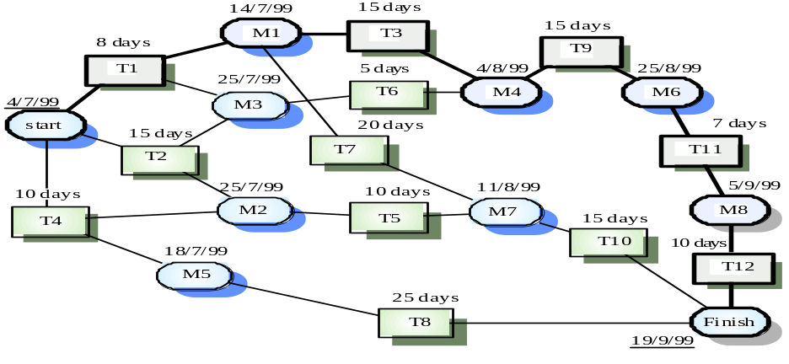

Task durations and dependencies

Given dependency and estimated duration of activities, and activity network that shows activity sequences may be generated. It shows which activities can be carried out in parallel and which must be executed in sequence because of a dependency on an earlier activity. Activities are represented as rectangles. Milestones and project deliverables are shown with rounded corners. Dates in this diagram show the start date of the activity and are written in British style where the day precedes the month. You should read the network from left to right and from top to bottom.
In the project management tool used to produce this chart, all activities must end in milestones. An activity may start when its preceding milestone (which may depend on several activities) has been reached. Therefore, in the third column in figure the corresponding milestone (e.g. M5) has been shown which is reached when the tasks in that column finish.
Before progress can be made form one milestone to another, all paths leading to it must be complete. For example, task T9, shown in the activity network below cannot be started until tasks T3 and T are finished. The arrival at milestone M4 shows that these tasks have been completed.
The minimum required to finish the project can be estimated be considering the longest part in the activity graph (the critical path). In this case, it is 11 weeks of elapsed time or 55 working days. In the activity network diagram the critical path is shown as a sequence of emboldened boxes. The overall schedule of the project depends on the critical path. Any slippage in the completion of any critical activity causes project delays.
Delays in activities, which do not lie on the critical path, however, need not cause an overall schedule slippage. So long as the delays do not extend these activities so much that the total time exceeds the critical path the project schedule will not be affected. For example, if T8 is delayed, it may not affect the final completion date of the project, as it does not lie on the critical path.
Managers also use activity networks when allocating project work. They can provide insights into activity dependencies, which are not intuitively obvious. It may be possible to modify the system design so that the critical path is shortened. The project schedule may be shortened because of the reduced amount of time spent waiting for activities to finish.

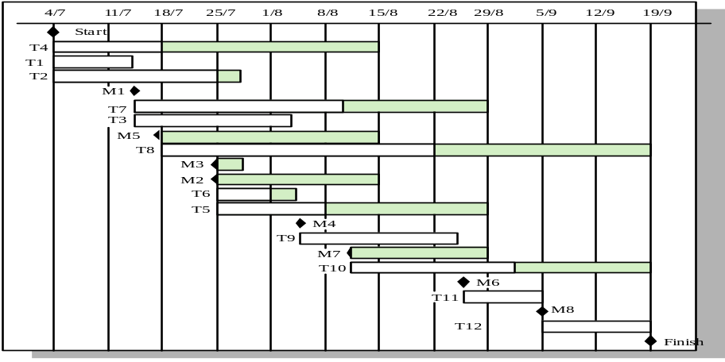

Activity Bar Chart

Figure with the gantt cart is an alternative way of representing project schedule information. It is a bar chart (sometimes called a Gantt chart, after its inventor) showing a project calendar and the start and finish dates of activities.
Some of the activities in the Gantt chart are followed by a shaded bar whose length is computed by the scheduling tool. This shows that there is some flexibility in the completion date of these activities. If an activity does not complete on time, the critical path will not be affected until the end of the period marked by the shaded bar. Activities, which lie on the critical path, have no margin of error and they can be identified because they have no associated shaded bar.
As well as considering schedules, project managers must also consider resource allocation and, in particular, the allocation of staff to project activities. Below is a figure showing the allocation of people to activities.
Project management support tools can also process the figure and a bar chart generated which shows the time periods where staff is employed on the project. Staff doesn’t have to be assigned to a project at all time. During intervening periods they may be on holiday, working on other projects, attending training courses or some other activity.
Large organizations usually employ a number of specialists who work on a project as required. This can cause scheduling problems. If one project is delayed while a specialist is working on it, this may have a knock-on effect on other projects. They may also be delayed because the specialist is not available.

Allocation of People to Activities:

Task | Engineer
T1 | Jane
T2 | Anne
T3 | Jane
T4 | Fred
T5 | Mary
T6 | Anne
T7 | Jim
T8 | Fred
T9 | Jane
T10 | Anne
T11 | Fred
T12 | Fred
Staff Allocation:

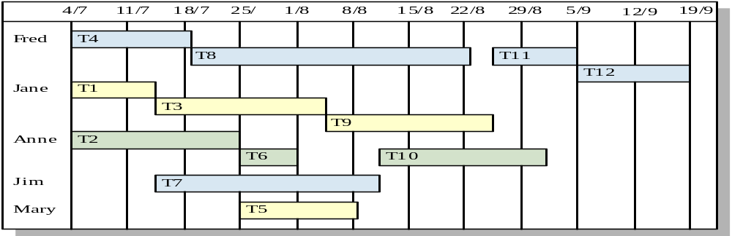

1.13. Tools and Technology with reasoning
The application tools, which are to be used on front and back end of the system to be developed, should be listed. The reasons for these tools should also be described.
Identify what the needs for tool support are, and what the constraints are, by looking at the following:
- The development process. What tool support is required to effectively work? For example, if the organization decide to employ an iterative development process, it is necessary to automate the tests, since you will be testing several times during the project.
- Host (or development) platform(s).
- Target platform(s).
- The programming language(s) to be used.
- Existing tools. Evaluate any existing and proven tools and decide whether they can continue to be used.
- The distribution of the development organization. Is the organization physically distributed? Development tools generally support a physically distributed organization differently.
- The size of the development effort. Tools support large organizations more or less well.
- Budget and time constraints

1.14. Vision Document
The Vision defines the stockholder’s view of the product to be developed, specified in terms of the stockholder’s key needs and features. Containing an outline of the envisioned core requirements, it provides the contractual basis for the more detailed technical requirements.
A Vision Document is the starting point for most software projects. It is the primary deliverable and is therefore the first document produced in the planning process. The main purpose of this document is to move the project forward into detailed project planning and ultimately into development.
The Vision Document is designed to make sure that key decision makers on both sides have a clear, shared vision of the objectives and scope of the project. It identifies alternatives and risks associated with the project. Finally, it presents a budget for the detailed planning phase for the stakeholders to approve.
The Vision document provides a high-level for the more detailed technical requirements. There can also be a formal requirements specification. The Vision captures very high-level requirements and design constraints to give the reader an understanding of the system to be developed. It provides input to the project-approval process and is, therefore, intimately related to the Business Case. It communicates the fundamental "whys and what's" related to the project and is a gauge against which all future decisions should be validated.
A project vision is meant to be changeable as the understanding of requirements, architecture, plans, and technology evolves. However, it should be changing slowly and normally throughout the earlier portion of the lifecycle.
It is important to express the vision in terms of its use cases and primary scenarios as these are developed, so that you can see how the vision is realized by the use cases. The use cases also provide an effective basis for evolving a test case suite.
Another name used for this document is the Product Requirement Document. There are certain checkpoints that help to verify that the vision document is fulfilled.
Checkpoints:
- Have you fully explored what the "problem behind the problem" is?
- Is the problem statement correctly formulated?
- Is the list of stakeholders complete and correct?
- Does everyone agree on the definition of the system boundaries?
- If system boundaries have been expressed using actors, have all actors been defined and correctly described?
- Have you sufficiently explored constraints to be put on the system?
- Have you covered all kinds of constraints - for example political, economic, and environmental?
- Have all key features of the system been identified and defined?
- Will the features solve the problems that are identified?
- Are the features consistent with constraints that are identified?

1.15. Risk List
The possibility of suffering harm or loss in terms of danger is called risk. Regarding the importance of risks a list is to be maintained. Risk list is a sorted list of known, open risks to the project, sorted in decreasing order of importance, associated with specific mitigation or contingency actions.
Purpose
The Risk List is designed to capture the perceived risks to the success of the project. It identifies, in decreasing order of priority, the events that could lead to a significant negative outcome. It serves as a focal point for project activities and is the basis around which iterations are organized
The Risk List is maintained throughout the project. It is created early in the Inception phase, and is continually updated as new risks are uncovered and existing risks are mitigated or retired. At a minimum, it is revisited at the end of each iteration, as the iteration is assessed.

1.16. Product Features/ Product Decomposition
Functional requirements capture the intended behavior of the system. This behavior may be expressed as services, tasks or functions the system is required to perform.

Chapter 2: Software Requirement Specification

2.1 Introduction:
Requirements engineering process provides the appropriate mechanism for understanding what the customer wants, analyzing need, assessing feasibility, negotiating a reasonable solution, specifying the solution unambiguously, validating the specification and managing the requirements as they are transformed into an operational system. The task of capturing, structuring, and accurately representing the user's requirements so that they can be correctly embodied in systems which meet those requirements (i.e. are of good quality).

- Requirements elicitation
- Requirements analysis and negotiation
- Requirements specification
- System modeling
- Requirements validation
- Requirements management

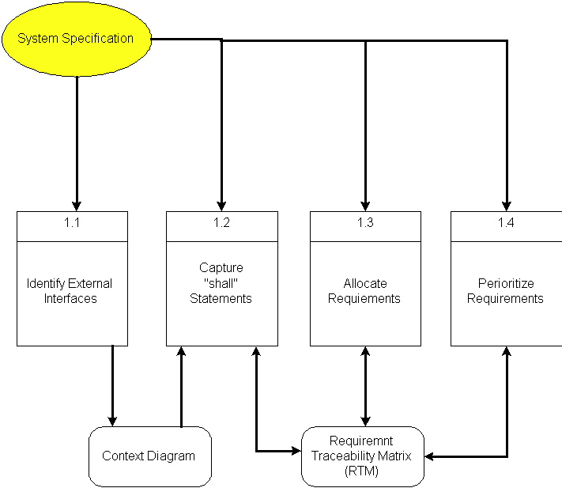

Here, requirements specification is to be discussed. Requirements specification would lead to the following four steps:
- Identify external interfaces
- Development of context diagram
- Capture “shall statements
- Allocate requirements
- Prioritize requirements
- Development of requirements traceability matrix

2.1.1 Systems Specifications
The following are the clauses that must be included while describing the system specifications.
Introduction
This clause should contain brief “Introduction” of the system under discussion domain knowledge. It can also contain company, its location, its historical background and its current status in the market. The most important part of this clause is to give an overview of the major business areas of the company. This overview must be very brief so that one can get a bird’s eye view of the organization under study.
Existing System
This clause must be focusing on providing a comprehensive detail of main business areas of the organizations that we have just mentioned in the previous clause. But here the discussion should be more elaborative.
Organizational Chart
Organizational chart will be very much supportive to get a better overview of the organization’s business areas and their decomposition into different departments.
Scope of the System
The Scope may include the boundaries of the system under study. To what domain you want to restrict your project must be clearly mentioned in this clause.
Summary of Requirements: (Initial Requirements)
An abstract is necessary at this stage to give an understanding of the initial requirements of the system. This will show what high level requirements the proposed system must address. This abstract will act as a foundation for the future analysis of the system.

2.1.2. Identifying External Entities
The identification of the external entities will be based on the information contained in your Abstract. This identification is done after two phases. We will map the “Green wood” case study to make things more comprehensible.

The Identification of External Entities is done in two phases.

a. Over Specify Entities from Abstract:
On the basis of the Abstract, one might identify the entities from the problem.
b. Perform Refinement:
After over specifying the entities, you have to refine them on the basis of your business logic. For example, in this example we found the following entities more related to our business logic;

2.1.3. Context Level Data Flow Diagram:
Context level data flow diagram contains only one process, representing the entire system. The process is given the number zero and all external entities are shown on the context diagram as well as major data flow to and from them. The diagram does not contain any data stores.

2.1.4. Capture "shall" Statements:
Identify “shall” statements, as they would be all functional requirements.

2.1.5. Allocate Requirements:
Allocate the requirements in the use cases.

2.1.6. Prioritize Requirements:
Requirements must be prioritized as this will help achieve tasks easily. Rank them as “highest, medium, and lowest”.

2.1.7. Requirements Trace-ability Matrix:
The requirements trace-ability matrix is a table used to trace project life cycle activities and work products to the project requirements. The matrix establishes a thread that traces requirements from identification through implementation.

2.2. Example:
Here is an example to explain all the above. We are taking the system of Green Wood Company.

2.2.1. Introduction
Green Wood (GW) is a multinational company, which deals in manufacturing, delivery and selling of sports goods and sports ware throughput the world. GW deals in almost all types of support goods and has its manufacturing set-up in Sialkot, Pakistan. They have their own products selling outlets and showrooms throughout the world. They also supply their goods to other dealers on wholesale ordering basis. Currently GW is managing their operations manually. GW management has decided to completely automate the whole business processes of the company. Also in order to increase their sales, GW wants to have fully automated system, which can support online 24x7 electronic buying and selling.

2.2.2. Existing System
Business Organization
GW deals in following three main business areas:

- Sport goods manufacturing
- Sport goods ordering and supply
- Consumer Outlets & Showrooms

Following departments/offices facilitates above mentioned business services:

Sport Goods Manufacturing Department
Deals in manufacturing of sport goods.

GW Supplier Office
It deals in supply of sport goods to their own selling outlets or to other dealers. It also processes orders from the dealers. Following are some business processes, which are handled in this department.

- Order Management
- Customer Account Maintenance
- Order Processing
- Shipping Department
- Product Inventory
- Accounts & Administration
- CRM
- MIS
- HRM & Pay Roll
- Sales & Marketing

GW Consumer Outlets & Showrooms
They directly deals with buying and selling of goods to customers
- Shopping Centre
- Stock Maintenance
Business Organization Chart

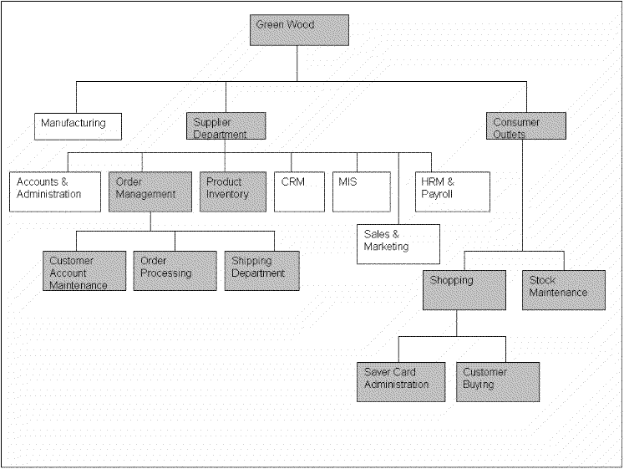

2.2.3. Scope of the System
The GW System is divided in to three phases.

Phase I
Phase I includes following business areas:
- Customer Account Maintenance
- Order Processing
- Product Inventory

Phase II
Phase II involves complete automation of the Supplier Department. Phase II includes following business areas:
- Accounts and Administration
- CRM
- MIS
- HRM and Payroll
- Sales and Marketing

Phase III
Phase III covers a complete solution for Green Wood. Phase III includes remaining business areas which are not developed in previous phases.
This document scope is limited to Phase I only.

2.2.4. Business Model
A business model is an outline of how a company plans to make money with its product and customer base in a specific market. At its core, a business model explains four things:
- What product or service a company will sell.
- How it intends to market that product or service.
- What kind of expenses it will face.
- How it expects to turn a profit.

2.2.5. Summary of Requirements :( Initial Requirements)
The purposed system must fulfill following requirements as follow:

2.2.5.1. Supplier Department Requirements

Order Management

1. Only registered customer could place order for goods. So a customer must be able to register himself to the system by requesting for registration. There should have to be two types of registration process, normal and privileged. Customer should provide his personal, organizational, authorizer and payment details in the registration request process. All the requests are to be viewed by the customer account administrator (CA). CA could accept, reject and temporarily waive the requests on the basis of credentials provided. If admin accept the registration request, a login information (Password, Id & role) should be assigned and mailed to the corresponding customer. Similarly customer could also request for the updating of his record. He could request for different types of updating e.g. updating of his personal/shipping details, or upgrading of his status from registered to privileged customer, or updating of his payment methodology. Customer could also view his details for verification purposes and similarly CA could search any customer detail and could also view the whole list of currently registered customers.

2. Both registered and privileged customers could order for goods. Customer places an order by providing his ID and other order related details A complete order must contain personal details of the customer, shipping information, product list along with product quantity and payment details. Customer could make payment either through cash or through a credit card. Accordingly invoice should be generated, and user should be given the option to finally place the order and in the end confirmation receipt must be given to the customer. Invoice contains the list of complete product along with their pricing details. It also contains discounts, sales tax and total pricing details. User could also view the status of their orders by providing the Order Number. Privileged customers could also place the request for the updating of their orders if the orders are not shipped. They could place request for the updating of shipping address and product quantity only. Similarly the privileged customer could also place the request for the cancellation of the order. But all these updating and cancellation requests are to be viewed by the Order Administrator in order to accept, reject, or waive them.

3.Action List mechanism should be adopted for better notification/messaging services, business interaction and control. An action event should be generated for a corresponding administrator when a request is placed for updating of orders or customer details etc. These actions could be generated by the Order Operator or through the updating process. Similarly on the other hand corresponding administrator could view his Action List containing different actions, and correspondingly process these pending actions. Similarly when the action processing is completed or if the action is just a notification message then administrator could delete these actions from the action list. Actions List configuration should be done by System Admin, who could add new action events and delete any current event from the system.

4. Shipping Department ships the corresponding orders.

2.2.5.2. Product Inventory

Deals with addition, searching, updating of products and their stocks. Whenever a product stock arrives, the Inventory Administrator updates the stocks of the products. He could add new product in the inventory. He could also view, search and modify the product details. The Admin could view the whole product list and their product summaries.

2.2.5.3. Consumer Dealing Department Requirements
Deals with front office customer dealing related to goods sales and marketing.

Shopping Centre
- Deals with customer registration and saver card administration
- Also deals with customer buying and returning of goods

2.2.5.4. Product Stock Maintenance
Deals with addition, searching, updating of products and their stocks.

2.2.6. Identifying External Entities:
The identification of the external entities will be based on the information contained in your Abstract. This identification is done after two phases. We will map the “Green wood” case study to make things more comprehensible.

The Identification of External Interfaces is done in two phases.

Over Specify Entities from Abstract:
On the basis of the Abstract, one might identify the following entities from the Green Wood case study.

- Customer
- Order
- Order Product
- Shipment
- Invoice
- Product
- Payment
- Account
- Credit Card
- Cheque
- Request

Perform Refinement:
After over specifying the entities, you have to refine them on the basis of your Business Logic. For example, in this example we found the following entities more related to our Business Logic;

- Customer
- Inventory
- Shipment
- Account

2.2.7. Capture "shall" Statements:

Para # | Initial Requirements
1.0 | A customer “shall” place order for goods
1.0 | A customer “shall” register himself to the system
1.0 | The system “shall” provide two types of registration process, normal and privileged
1.0 | CA “shall” accept, reject and temporarily waive the requests on the basis of credentials provided.
1.0 | A customer “shall” login to the system and can change his password
1.0 | System “shall” update the customers Request
1.0 | System “shall” process different types of updating e.g. updating of his personal/shipping details, or upgrading of his status from registered to privileged customer, or updating of his payment methodology
1.0 | A customer “shall” view his details for verification purposes
1.0 | CA “shall”accept, reject and temporarily waive the requests on the basis of credentials provided.
1.0 | System “shall” search any customer details
2.0 | Both registered and privileged customers “will”order for goods.
2.0 | Customer “shall” make payment; either through cash or through a credit card
2.0 | System “shall” generate invoice, confirmation receipt and finally will place order
2.0 | User “shall” view the status of their orders by providing the Order Number
2.0 | Privileged customers “shall”place the request for the updating of their orders if the orders are not shipped.
2.0 | Privileged customer “shall” place the request for the cancellation of the order. But all these updating and cancellation requests are to be viewed by the Order Administrator in order to accept, reject, or waive them.
3.0 | An action event "shall" be generated for a corresponding administrator when a request is placed for updating of orders or customer details etc
3.0 | Corresponding administrator "shall" view his Action List containing different actions, and correspondingly process these pending actions
3.0 | When the action processing is completed or if the action is just a notification message then administrator "shall" delete these actions from the action list

2.2.8. Allocate Requirements:

Para # | Initial Requirements | Use Case Name
1.0 | A customer “will” place order for goods | UC_Place_Order
1.0 | A customer “shall” register himself to the system | UC_Registration_Request
1.0 | The system “shall” provide two types of registration process, normal and privileged | UC_Place_Order_Request
1.0 | CA “shall”accept, reject and temporarily waive the requests on the basis of credentials provided. | UC_Process_Customer_Request
1.0 | A customer “shall” login to the system and can change his password | UC_Login
1.0 | System “shall” update the customers Request | UC_Update_Request
1.0 | System “shall” process different types of updating e.g. updating of his personal/shipping details, or upgrading of his status from registered to privileged customer, or updating of his payment methodology | UC_Change_Status
1.0 | A customer “shall” view his details for verification purposes | UC_View_Customer_Details
1.0 | System “shall” search any customer details | UC_Search_Customer
1.0 | CA “shall”accept, reject and temporarily waive the requests on the basis of credentials provided. | UC_Accept_Customer_Request  UC_Reject_Customer_Request  UC_View_Customer_Request
2.0 | Both registered and privileged customers “will”order for goods. | UC_Place_Order_Privleged
2.0 | Customer “will” make payment; either through cash or through a credit card | UC_Pay_For_Order
2.0 | System “will” generate invoice, confirmation receipt and finally will place order | UC_Invoice_Generation,
2.0 | User “shall” view the status of their orders by providing the Order Number | UC_Serach_Orders
2.0 | Privileged customers “shall”place the request for the updating of their orders if the orders are not shipped. | UC_Update_Request
2.0 | Privileged customer “shall” place the request for the cancellation of the order. But all these updating and cancellation requests are to be viewed by the Order Administrator in order to accept, reject, or waive them. | UC_Change_Payment_Details,  UC_Change_Status,  UC_Change_Personal_Details
3.0 | The System “shall” generate an action event for a corresponding administrator when a request is placed for updating of orders or customer details etc | UC_Create_Action,
3.0 | Corresponding administrator “shall ” view his Action List containing different actions, and correspondingly process these pending actions | UC_View_Action,

2.2.9. Priorities Requirements:

Para # | Rank | Initial Requirements | Use Case ID | Use Case Name
1.0 | Highest | A customer “will” place order for goods | UC_1 | UC_PlaceOrder
1.0 | Highest | A customer “shall” register himself to the system | UC_2 | UC_Registration_Request
2.0 | Highest | Customer “will” make payment either through cash or through a credit card | UC_3 | UC_Pay_For_Order
2.0 | Highest | System “will” generate invoice, confirmation receipt and finally will place order | UC_4 | UC_Invoice_Generation,
2.0 | Medium | Both registered and privileged customers “will”order for goods. | UC_5 | UC_Place_Order_Privleged
1.0 | Medium | The system “shall” provide two types of registration process, normal and privileged | UC_6 | UC_Place_Order_Request
3.0 | Medium | The System “shall” generate an action event for a corresponding administrator when a request is placed for updating of orders or customer details etc | UC_7 | UC_Create_Action
1.0 | Medium | CA “shall”accept, reject and temporarily waive the requests on the basis of credentials provided. | UC_8  UC_9  UC_10 | UC_Accept_Customer_Request  UC_Reject_Customer_Request  UC_View_Customer_Request
1.0 | Medium | System “shall” update the customers Request | UC_11 | UC_Update_Request
1.0 | Medium | System “shall” process different types of updating e.g. updating of his personal/shipping details, or upgrading of his status from registered to privileged customer, or updating of his payment methodology | UC_12  UC_13  UC_14 | UC_Change_Payment_Details,  UC_Change_Status,  UC_Change_Personal_Details
1.0 | Medium | A customer “shall” view his details for verification purposes | UC_15 | UC_View_Customer_Details
1.0 | Medium | System “shall” search any customer details | UC_16 | UC_Search_Customer
2.0 | Medium | User “shall” view the status of their orders by providing the Order Number | UC_17 | UC_Serach_Orders
2.0 | Medium | Privileged customers “shall”place the request for the updating of their orders if the orders are not shipped. | UC_18 | UC_Update_Request
2.0 | Medium | Privileged customer “shall” place the request for the cancellation of the order. But all these updating and cancellation requests are to be viewed by the Order Administrator in order to accept, reject, or waive them. | UC_19  UC_20  UC_21 | UC_View_All_Orders  UC_Manage_Order
1.0 | Lowest | A customer “shall” login to the system and can change his password | UC_22  UC_23 | UC_Login,
3.0 | Lowest | Corresponding administrator “shall ” view his Action List containing different actions, and correspondingly process these pending actions | UC_24 | UC_View_Action,
3.0 | Lowest | When the action processing is completed or if the action is just a notification message then administrator “shall” delete these actions from the action list | UC_25 | UC_Delete_Action

2.2.10. Requirements Traceability Matrix:

Sr# | Para # | System Specification Text | Build | Use Case Name | Category
1 | 1.0 | A customer “will” place order for goods | B1 | UC_Place_Order | Business
2 | 1.0 | A customer “shall” register himself to the system | B1 | UC_Registration_Request | Business
3 | 1.0 | The system “shall” provide two types of registration process, normal and privileged | B1 | UC_PlaceOrderRequest,  UC_PlaceCustomerRequest | Business
4 | 1.0 | CA “shall”accept, reject and temporarily waive the requests on the basis of credentials provided. | B1 | UC_Accept_Customer_Request  UC_Reject_Customer_Request  UC_View_Customer_Request | Business
5 | 1.0 | A customer “shall” login to the system and can change his password | B1 | UC_Login, | Business
6 | 1.0 | System “shall” update the customers Request | B1 | UC_Update_Request | Business
7 | 1.0 | System “shall” process different types of updating e.g. updating of his personal/shipping details, or upgrading of his status from registered to privileged customer, or updating of his payment methodology | B1 | UC_Change_Payment_Details,  UC_Change_Status,  UC_Change_Personal_Details | Business
8 | 1.0 | A customer “shall” view his details for verification purposes | B1 | UC_View_Customer_Details | Business
9 | 1.0 | System “shall” search any customer details | B1 | UC_SearchCustomer | Business
10 | 2.0 | Both registered and privileged customers “will”order for goods. | B1 | UC_Place_Order_Privellged | Business
11 | 2.0 | Customer “will” make payment; either through cash or through a credit card | B1 | UC_Pay_For_Order | Business
12 | 2.0 | System “will” generate invoice, confirmation receipt and finally will place order | B1 | UC_Invoice_Generation | Business

2.2.11. High Level Use case Diagram:
A use case scenario is a visual description, typically written in structured English or point form, of a potential business situation that a system may or may not be able to handle.
A use case defines a goal-oriented set of interactions between external actors and the system under consideration.
A use case is initiated by a user with a particular goal in mind, and completes successfully when that goal is satisfied. It describes the sequence of interactions between actors and the system necessary to deliver the service that satisfies the goal. It also includes possible variants of this sequence, e.g., alternative sequences that may also satisfy the goal, as well as sequences that may lead to failure to complete the service because of exceptional behavior, error handling, etc. The system is treated as a “black box”, and the interactions with system, including system responses, are as perceived from outside the system.
Thus, use cases capture who (actor) does what (interaction) with the system, for what purpose (goal), without dealing with system internals. A complete set of use cases specifies all the different ways to use the system, and therefore defines all behavior required of the system, bounding the scope of the system.
Generally, use case steps are written in an easy-to-understand structured narrative using the vocabulary of the domain. This is engaging for users who can easily follow and validate the use cases, and the accessibility encourages users to be actively involved in defining the requirements.

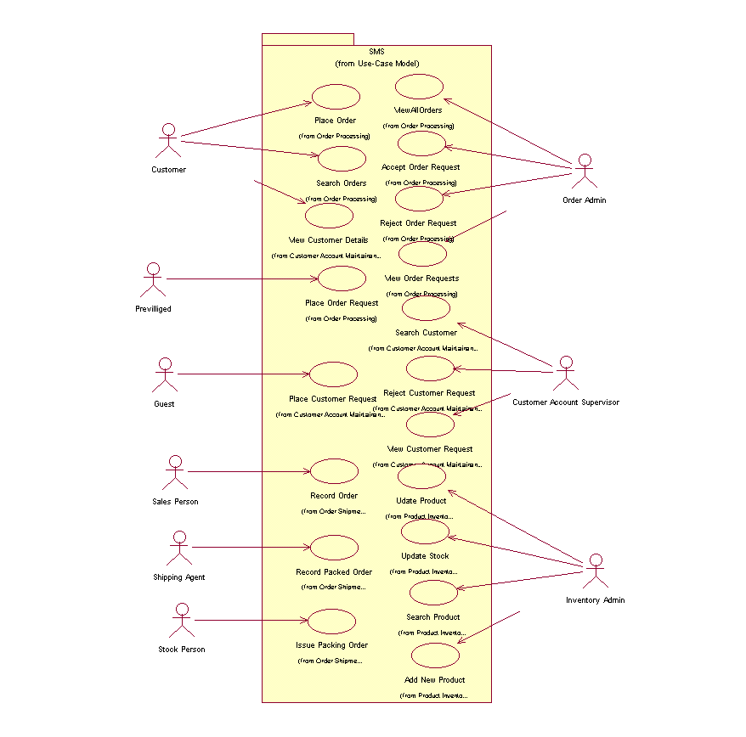
Example:

2.2.12. Analysis Level Usecase Diagram:
Analysis level usecase diagram is actually the explanation of high level usecas diagram. In this diagram high level usecases are expanded in a way that exhibit how high level usecases will reach to their functionality. Two types of relationships are used in this diagram. Which are:
- Extend
- Include

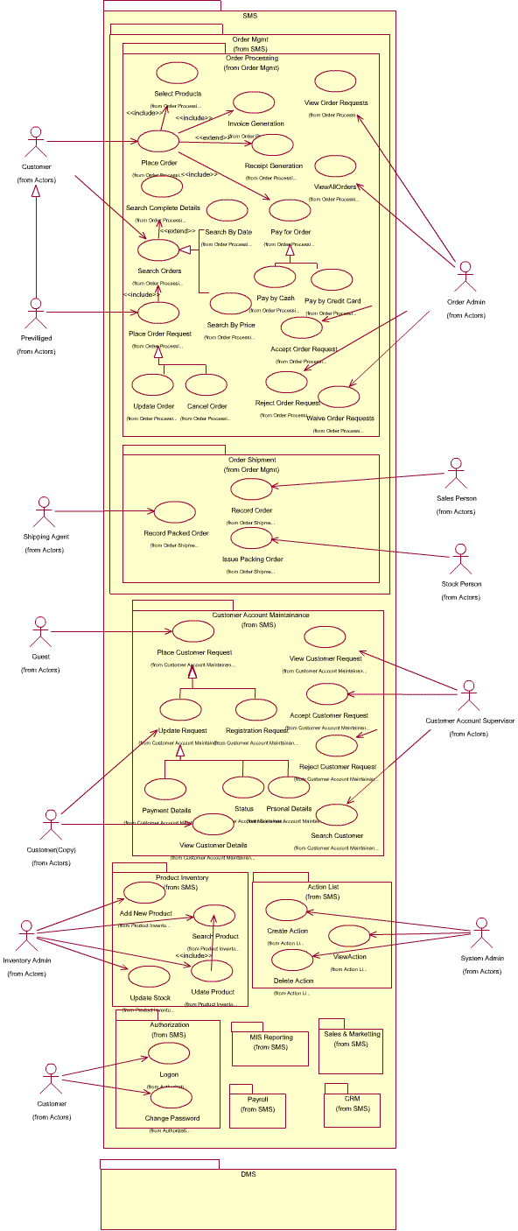

2.2.13. Usecase Description
While technically not part of UML, use case documents are closely related to UML use cases. A use case document is text that captures the detailed functionality of a use case. Such documents typically contain the following parts:

Brief description
Used to describe the overall intent of the use case. Typically, the brief description is only a few paragraphs, but it can be longer or shorter as needed. It describes what is considered the happy path—the functionality that occurs when the use case executes without errors. It can include critical variations on the happy path, if needed.

Preconditions
Conditionals that must be true before the use case can begin to execute. Note that this means the author of the use case document does not need to check these conditions during the basic flow, as they must be true for the basic flow to begin.

Basic flow
Used to capture the normal flow of execution through the use case. The basic flow is often represented as a numbered list that describes the interaction between an actor and the system. Decision points in the basic flow branch off to alternate flows. Use case extension points and inclusions are typically documented in the basic flow.

Alternate flows
Used to capture variations to the basic flows, such as user decisions or error conditions. There are typically multiple alternate flows in a single use case. Some alternate flows rejoin the basic flow at a specified point, while others terminate the use case.

Post conditions
Conditions that must be true for the use case to completed. Post conditions are typically used by the testers to verify that the realization of the use case is implemented correctly.

Chapter 3: Software Architecture and Design

3.1. Introduction:
Third deliverable is all about the software design. In the previous deliverable, analysis of the system is completed. So we understand the current situation of the problem domain. Now we are ready to strive for a solution for the problem domain by using object-oriented approach. Following artifacts must be included in the 3rd deliverable.

- Domain Model
- System Sequence Diagram
- Sequence Diagram
- Collaboration Diagram
- Operation Contracts
- Design Class Diagram
- State Transition Diagram
- Data Model

Now we discuss these artifacts one by one as follows:

3.2. Domain Model
Domain models represent the set of requirements that are common to systems within a product line. There may be many domains, or areas of expertise, represented in a single product line and a single domain may span multiple product lines. The requirements represented in a domain model include:

- Definition of scope for the domain
- Information or objects
- Features or use cases, including factors that lead to variation
- Operational/behavioral characteristics

A product line definition will describe the domains necessary to build systems in the product line.

What is domain modeling?
According to Rational Unified Process,® or RUP,® a domain model is a business object model that focuses on "product, deliverables, or events that are important to the business domain." A domain model is an "incomplete" business model, in that it omits individual worker responsibilities. The point of domain modeling is to provide "the big picture" of the interrelationships among business entities in a complex organization. The domain model typically shows the major business entities, and the relationships among the entities. A model that typically does not include the responsibilities people carry is often referred to as a domain model.
It also provides a high-level description of the data that each entity provide. Domain modeling plays a central role in understanding the current environment and planning.

- The typical steps involved in domain modeling are:
- Illustrate meaningful conceptual classes in a real-world problem domain
- Identify conceptual classes or domain objects
- Show associations between them
- Indicate their attributes when appropriate
- Purposely incomplete

3.3. Architecture/Design Pattern
An architectural pattern is a general, reusable solution to a commonly occurring problem in software architecture within a given context. The architectural patterns address various issues in software engineering, such as computer hardware performance limitations, high availability and minimization of a business risk.

3.3.1. Factory Method
Define an interface for creating a single object, but let subclasses decide which class to instantiate. Factory Method lets a class defer instantiation to subclasses.

3.3.2. Adapter
Convert the interface of a class into another interface clients expect. An adapter lets classes work together that could not otherwise because of incompatible interfaces. The enterprise integration pattern equivalent is the translator.

3.3.3. Façade
Provide a unified interface to a set of interfaces in a subsystem. Facade defines a higher-level interface that makes the subsystem easier to use.

3.3.4. MVC
The MVC pattern is one of the most commonly used in any web application to build User Interfaces. The MVC pattern stands for Model View Controller and is a commonly used web application Design Pattern that helps the overall User Experience.
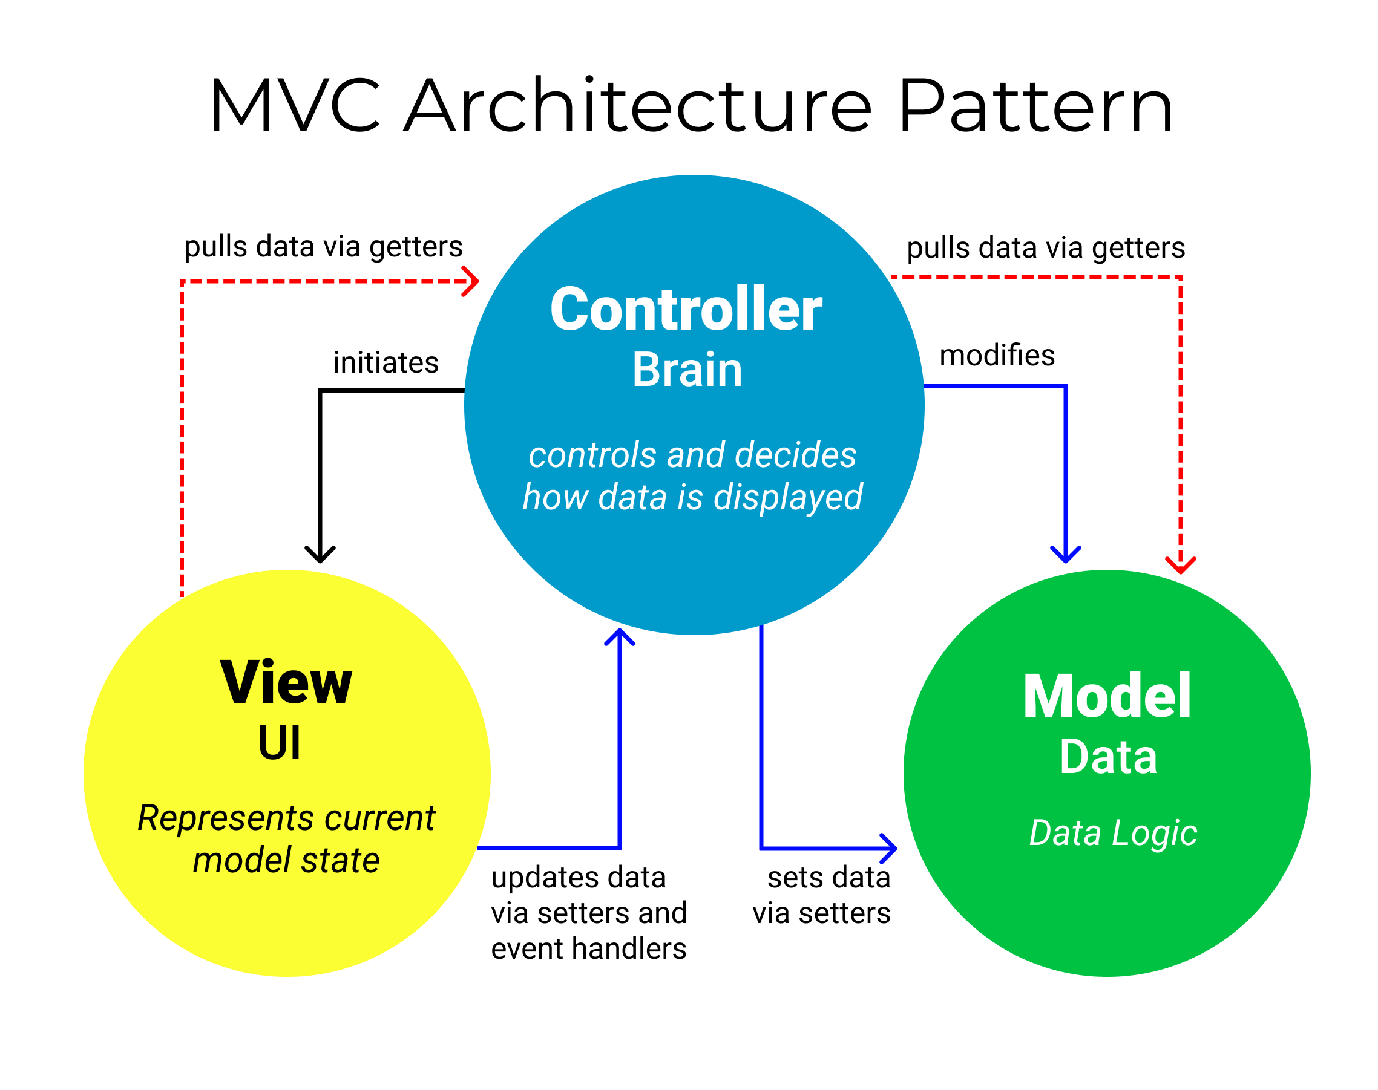

3.3.4.1. Model Responsibilities
The Model in an MVC application represents the state of the application and any business logic or operations that should be performed by it. Business logic should be encapsulated in the model, along with any implementation logic for persisting the state of the application. Strongly-typed views typically use ViewModel types designed to contain the data to display on that view. The controller creates and populates these ViewModel instances from the model.

3.3.4.2. View Responsibilities
Views are responsible for presenting content through the user interface. They use the Razor view engine to embed .NET code in HTML markup. There should be minimal logic within views, and any logic in them should relate to presenting content. If you find the need to perform a great deal of logic in view files in order to display data from a complex model, consider using a View Component, ViewModel, or view template to simplify the view.

3.3.4.3. Controller Responsibilities
Controllers are the components that handle user interaction, work with the model, and ultimately select a view to render. In an MVC application, the view only displays information; the controller handles and responds to user input and interaction. In the MVC pattern, the controller is the initial entry point, and is responsible for selecting which model types to work with and which view to render (hence its name - it controls how the app responds to a given request).

3.4. Algorithm Flow Chart

A flowchart is a graphical representation of an algorithm. Programmers often use it as a program-planning tool to solve a problem. It makes use of symbols which are connected among them to indicate the flow of information and processing.
The process of drawing a flowchart for an algorithm is known as “flowcharting”.
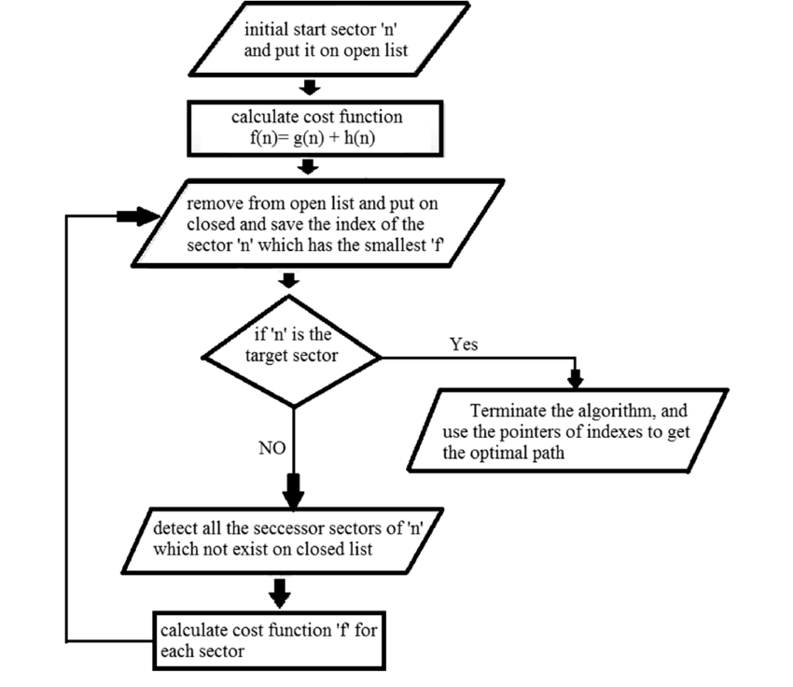

3.5 System Sequence Diagram

The UML system sequence diagram (SSD) illustrates events sequentially input from an external source to the system. The SSD will define the system events and operations. System sequence diagrams are a timeline drawing of an expanded use case. Events are related by time with the top events occurring first. System events are the important items. These are events that cause a system response.

Use case text may be placed on the left side of the system sequence diagram if desired. If this is done it is best if the use case information lines up with the events in the system sequence diagram.
There may be more than one actor to the system. An actor may be an external automated system that the system may communicate with. Automated actors or robots are shown as actors with a line horizontally through the head.

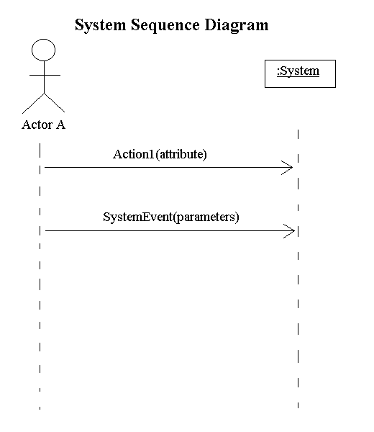

3.6. Sequence Diagram

A Sequence diagram depicts the sequence of actions that occur in a system. The invocation of methods in each object, and the order in which the invocation occurs is captured in a Sequence diagram. This makes the Sequence diagram a very useful tool to easily represent the dynamic behavior of a system.
A Sequence diagram is two-dimensional in nature. On the horizontal axis, it shows the life of the object that it represents, while on the vertical axis, it shows the sequence of the creation or invocation of these objects.
Because it uses class name and object name references, the Sequence diagram is very useful in elaborating and detailing the dynamic design and the sequence and origin of invocation of objects. Hence, the Sequence diagram is one of the most widely used dynamic diagrams in UML.

3.6.1. Defining a Sequence diagram
A sequence diagram is made up of objects and messages. Objects are represented exactly how they have been represented in all UML diagrams—as rectangles with the underlined class name within the rectangle.
Sequence diagrams describe interactions among classes in terms of an exchange of messages over time.

3.6.2. Basic Sequence Diagram Symbols and Notations

Class roles
Class roles describe the way an object will behave in context. Use the UML object symbol to illustrate class roles, but don't list object attributes.

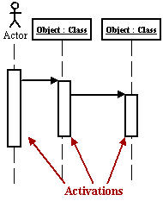
Activation
Activation boxes represent the time an object needs to complete a task.

Messages
Messages are arrows that represent communication between objects. Use half-arrowed lines to represent asynchronous messages. Asynchronous messages are sent from an object that will not wait for a response from the receiver before continuing its tasks.

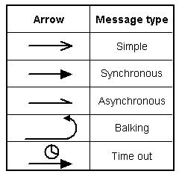
Lifelines
Lifelines are vertical dashed lines that indicate the object's presence over time.

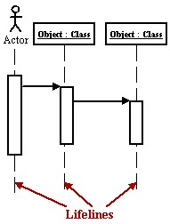
Destroying Objects
Objects can be terminated early using an arrow labeled "< < destroy > >" .
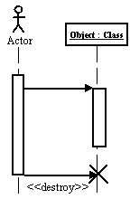

Loops
A repetition or loop within a sequence diagram is depicted as a rectangle. Place the condition for exiting the loop at the bottom left corner in square brackets [ ].

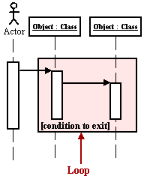

Objects
An object is shown as a vertical dashed line called the "lifeline". The lifeline represents the existence of the object at a particular time. An object symbol is drawn at the head of the lifeline, and shows the name of the object and its class underlined, and separated by a colon:
objectname : classname

You can use objects in sequence diagrams in the following ways:

- A lifeline can represent an object or its class. Thus, you can use a lifeline to model both class and object behavior. Usually, however, a lifeline represents all the objects of a certain class.
- An object's class can be unspecified. Normally you create a sequence diagram with objects first, and specify their classes later.
- The objects can be unnamed, but you should name them if you want to discriminate different objects of the same class.
- Several lifelines in the same diagram can represent different objects of the same class; but, as stated previously, the objects should be named that so you can discriminate between the two objects.
- A lifeline that represents a class can exist in parallel with lifelines that represent objects of that class. The object name of the lifeline that represents the class can be set to the name of the class.

Actors
Normally an actor instance is represented by the first (left-most) lifeline in the sequence diagram, as the invoker of the interaction. If you have several actor instances in the same diagram, try keeping them either at the left-most, or the right-most lifelines.

Messages
A message is a communication between objects that conveys information with the expectation that activity will ensue; in sequence diagrams, a message is shown as a horizontal solid arrow from the lifeline of one object to the lifeline of another object. In the case of a message from an object to itself, the arrow may start and finish on the same lifeline. The arrow is labeled with the name of the message, and its parameters. The arrow may also be labeled with a sequence number to show the sequence of the message in the overall interaction. Sequence numbers are often omitted in sequence diagrams, in which the physical location of the arrow shows the relative sequence.
A message can be unassigned, meaning that its name is a temporary string that describes the overall meaning of the message and is not the name of an operation of the receiving object. You can later assign the message by specifying the operation of the message's destination object. The specified operation will then replace the name of the message.

Scripts
Scripts describe the flow of events textually in a sequence diagram.
You should position the scripts to the left of the lifelines so that you can read the complete flow from top to bottom (see figure above). You can attach scripts to a certain message, thus ensuring that the script moves with the message.

3.6.3. Example
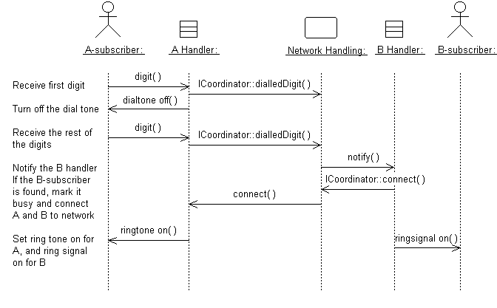
A sequence diagram that describes part of the flow of events of the use case Place Local Call in a simple Phone Switch.

3.6.4. Distributing Control Flow in Sequence Diagrams

Centralized control of a flow of events or part of the flow of events means that a few objects steer the flow by sending messages to, and receiving messages from other objects. These controlling objects decide the order in which other objects will be activated in the use case. Interaction among the rest of the objects is very minor or does not exist.

Example
In the Recycling-Machine System, the use case Print Daily Report keeps track of - among other things - the number and type of returned objects, and writes the tally on a receipt. The Report Generator control object decides the order in which the sums will be extracted and written.

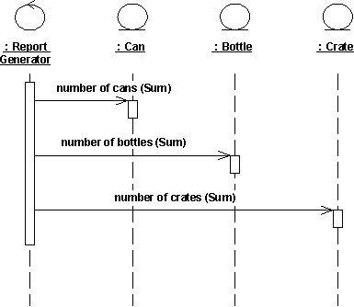

The behavior structure of the use case Print Daily Report is centralized in the Report Generator control object.
This is an example of centralized behavior. The control structure is centralized primarily because the different sub-event phases of the flow of events are not dependent on each other. The main advantage of this approach is that each object does not have to keep track of the next object's tally. To change the order of the sub-event phases, you merely make the change in the control object. You can also easily add still another sub-event phase if, for example, a new type of return item is included. Another advantage to this structure is that you can easily reuse the various sub-event phases in other use cases because the order of behavior is not built into the objects.

Decentralized control arises when the participating objects communicate directly with one another, not through one or more controlling objects.

Example
In the use case Send Letter someone mails a letter to another country through a post office. The letter is first sent to the country of the addressee. In the country, the letter is sent to a specific city. The city, in turn, sends the letter to the home of the addressee.
The behavior structure of the use case Send Letter is decentralized.
The use case behavior is a decentralized flow of events. The sub-event phases belong together. The sender of the letter speaks of "sending a letter to someone." He neither needs nor wants to know the details of how letters are forwarded in countries or cities. (Probably, if someone were mailing a letter within the same country, not all these actions would occur.)
The type of control used depends on the application. In general, you should try to achieve independent objects, that is, to delegate various tasks to the objects most naturally suited to perform them.
A flow of events with centralized control will have a "fork-shaped" sequence diagram. On the other hand, a "stairway-shaped" sequence diagram illustrates that the control-structure is decentralized for the participating objects.
A centralized control structure in a flow of events produces a "fork-shaped" sequence diagram. A decentralized control structure produces a "stairway-shaped" sequence diagram.
The behavior structure of a use-case realization most often consists of a mix of centralized and decentralized behavior.

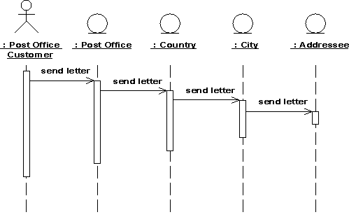

A decentralized structure is appropriate:
- If the sub-event phases are tightly coupled. This will be the case if the participating objects:
- Form a part-of or consists-of hierarchy, such as Country - State - City;
- Form an information hierarchy, such as CEO - Division Manager - Section Manager;
- Represent a fixed chronological progression (the sequence of sub-event phases will always be performed in the same order), such as Advertisement - Order - Invoice -Delivery - Payment; or
- Form a conceptual inheritance hierarchy, such as Animal - Mammal - Cat.
- If you want to encapsulate, and thereby make abstractions of, functionality. This is good for someone who always wants to use the whole functionality, because the functionality can become unnecessarily hard to grasp if the behavior structure is centralized.
- A centralized structure is appropriate:
- If the order in which the sub-event phases will be performed is likely to change.
- If you expect to insert new sub-event phases.
- If you want to keep parts of the functionality reusable as separate pieces.

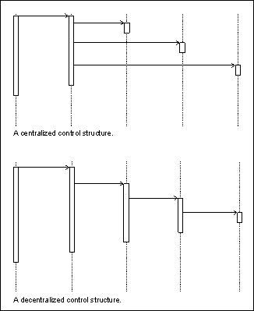

3.7. Collaboration Diagram
A collaboration diagram describes a pattern of interaction among objects; it shows the objects participating in the interaction by their links to each other and the messages that they send to each other.
Collaboration diagrams are used to show how objects interact to perform the behavior of a particular use case, or a part of a use case. Along with sequence diagrams, collaborations are used by designers to define and clarify the roles of the objects that perform a particular flow of events of a use case. They are the primary source of information used to determining class responsibilities and interfaces.
Unlike a sequence diagram, a collaboration diagram shows the relationships among the objects. Sequence diagrams and collaboration diagrams express similar information, but show it in different ways. Collaboration diagrams show the relationships among objects and are better for understanding all the effects on a given object and for procedural design.
Because of the format of the collaboration diagram, they tend to better suited for analysis activities. Specifically, they tend to be better suited to depicting simpler interactions of smaller numbers of objects. As the number of objects and messages grows, the diagram becomes increasingly hard to read. In addition, it is difficult to show additional descriptive information such as timing, decision points, or other unstructured information that can be easily added to the notes in a sequence diagram.

3.7.1. Contents of Collaboration Diagrams
You can have objects and actor instances in collaboration diagrams, together with links and messages describing how they are related and how they interact. The diagram describes what takes place in the participating objects, in terms of how the objects communicate by sending messages to one another. You can make a collaboration diagram for each variant of a use case's flow of events.

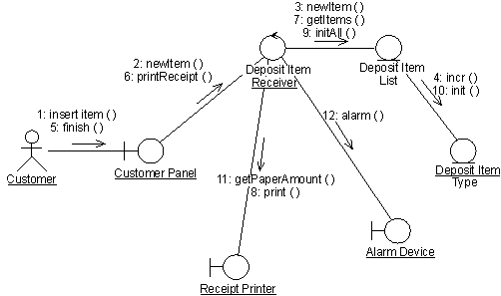

A collaboration diagram that describes part of the flow of events of the use case Receive Deposit Item in the Recycling-Machine System.

3.7.2. Constructs of Collaboration Diagram:

Objects
An object is represented by an object symbol showing the name of the object and its class underlined, separated by a colon:
objectname : classname
You can use objects in collaboration diagrams in the following ways:
An object's class can be unspecified. Normally you create a collaboration diagram with objects first and specify their classes later.
The objects can be unnamed, but you should name them if you want to discriminate different objects of the same class.
An object's class can itself be represented in a collaboration diagram, if it actively participates in the collaboration.

Actors
Normally an actor instance occurs in the collaboration diagram, as the invoker of the interaction. If you have several actor instances in the same diagram, try keeping them in the periphery of the diagram.

Links
Links are defined as follows:
A link is a relationship among objects across which messages can be sent. In collaboration diagrams, a link is shown as a solid line between two objects.
An object interacts with, or navigates to, other objects through its links to these objects.
A link can be an instance of an association, or it can be anonymous, meaning that its association is unspecified.
Message flows are attached to links.

Messages
A message is a communication between objects that conveys information with the expectation that activity will ensue. In collaboration diagrams, a message is shown as a labeled arrow placed near a link. This means that the link is used to transport, or otherwise implement the delivery of the message to the target object. The arrow points along the link in the direction of the target object (the one that receives the message). The arrow is labeled with the name of the message, and its parameters. The arrow may also be labeled with a sequence number to show the sequence of the message in the overall interaction. Sequence numbers are often used in collaboration diagrams, because they are the only way of describing the relative sequencing of messages.
A message can be unassigned, meaning that its name is a temporary string that describes the overall meaning of the message. You can later assign the message by specifying the operation of the message's destination object. The specified operation will then replace the name of the message.

3.8. Operation Contracts
A UML Operation contract identifies system state changes when an operation happens. Effectively, it will define what each system operation does. An operation is taken from a system sequence diagram. It is a single event from that diagram. A domain model can be used to help generate an operation contract.

Operation Contract Syntax

Name: appropriateName

Responsibilities: Perform a function

Cross References: System functions and Use Cases

Exceptions: none

Preconditions: Something or some relationship exists

Postconditions: An association was formed

When making an operation contract, think of the state of the system before the action (snapshot) and the state of the system after the action (a second snapshot). The conditions both before and after the action should be described in the operation contract. Do not describe how the action or state changes were done. The pre and post conditions describe state, not actions.
Typical postcondion changes:

- Object attributes were changed.
- An instance of an object was created.
- An association was formed or broken.
- Postconditions are described in the past tense. They declare state changes to the system. Fill in the name, then responsibilities, then postconditions.

3.9. Design Class Diagram
Classes are the work-horses of the design effort—they actually perform the real work of the system. The other design elements—subsystems, packages and collaborations simply describe how classes are grouped or how they interoperate.
Capsules are also stereotyped classes, used to represent concurrent threads of execution in real-time systems. In such cases, other design classes are 'passive' classes, used within the execution context provided by the 'active' capsules. When the software architect and designer choose not to use a design approach based on capsules, it is still possible to model concurrent behavior using 'active' classes.
Active classes are design classes, which coordinate and drive the behavior of the passive classes - an active class is a class whose instances are active objects, owning their own thread of control.

3.9.1. Create Initial Design Classes
Start by identifying one or several (initial) design classes from the domain model, and assign trace dependencies. The design classes created in this step will be refined, adjusted, split and/or merged in the subsequent steps when assigned various "design" properties, such as operations, methods, and a state machine, describing how the analysis class is designed.
Depending on the type of the analysis class (boundary, entity, or control) that is to be designed, there are specific strategies that can be used to create initial design classes.

3.9.2. Designing Boundary Classes
The general rule in analysis is that there will be one boundary class for each window, or one for each form, in the user interface. The consequence of this is that the responsibilities of the boundary classes can be on a fairly high level, and need then be refined and detailed in this step.
The design of boundary classes depends on the user interface (or GUI) development tools available to the project. Using current technology, it is quite common that the user interface is visually constructed directly in the development tool, thereby automatically creating user interface classes that need to be related to the design of control and/or entity classes. If the GUI development environment automatically creates the supporting classes it needs to implement the user interface, there is no need to consider them in design - only design what the development environment does not create for you.
Additional input to this work are sketches, or screen dumps from an executable user-interface prototype, that may have been created to further specify the requirements made on the boundary classes.
Boundary classes which represent the interfaces to existing systems are typically modeled as subsystems, since they often have complex internal behavior. If the interface behavior is simple (perhaps acting as only a pass-through to an existing API to the external system) one may choose to represent the interface with one or more design classes. If this route is chosen, use a single design class per protocol, interface, or API, and note special requirements about used standards and so on in the special requirements of the class.

3.9.3. Designing Entity Classes
During analysis, entity classes represent manipulated units of information; entity objects are often passive and persistent. In analysis, these entity classes may have been identified and associated with the analysis mechanism for persistence. Performance considerations may force some re-factoring of persistent classes, causing changes to the Design Model, which are discussed jointly between the Database Designer and the Designer.

3.9.4. Designing Control Classes
A control object is responsible for managing the flow of a use case and thus coordinates most of its actions; control objects encapsulate logic that is not particularly related to user interface issues (boundary objects), or to data engineering issues (entity objects). This logic is sometimes called application logic, or business logic.
Given this, at least the following issues need to be taken into consideration when control classes are designed:

Complexity:
Simple controlling or coordinating behavior can be handled by boundary and/or entity classes. As the complexity of the application grows, however, significant drawbacks to this approach surface:
- The use case coordinating behavior becomes imbedded in the UI, making it more difficult to change the system.
- The same UI cannot be used in different use case realizations without difficulty.
- The UI becomes burdened with additional functionality, degrading its performance.
- The entity objects may become burdened with use-case specific behavior, reducing their generality.
To avoid these problems, control classes are introduced to provide behavior related to coordinating flows-of-events

Change probability
If the probability of changing flows of events is low, or the cost is negligible, the extra expense and complexity of additional control classes may not be justified.

Distribution and performance
The need to run parts of the application on different nodes or in different process spaces introduces the need for specialization of design model elements. This specialization is often accomplished by adding control objects and distributing behavior from the boundary and entity classes onto the control classes. In doing this, the boundary classes migrate toward providing purely UI services, and the entity classes toward providing purely data services, with the control classes providing the rest.

Transaction management:
Managing transactions is a classic coordination activity. Absent a framework to handle transaction management, one would have one or more transaction manager classes which would interact to ensure that the integrity of transactions is maintained.
Note that in the latter two cases, if the control class represents a separate thread of control it may be more appropriate to use an active class to model the thread of control.

3.9.5. Identify Persistent Classes
Classes which need to be able to store their state on a permanent medium are referred to as 'persistent'. The need to store their state may be for permanent recording of class information, for back-up in case of system failure, or for exchange of information. A persistent class may have both persistent and transient instances; labeling a class 'persistent' means merely that some instances of the class may need to be persistent.
Identifying persistent classes serves to notify the Database Designer that the class requires special attention to its physical storage characteristics. It also notifies the Software Architect that the class needs to be persistent, and the Designer responsible for the persistence mechanism that instances of the class need to be made persistent.
Because of the need for a coordinated persistence strategy, the Database Designer is responsible for mapping persistent classes into the database, using a persistence framework. If the project is developing a persistence framework, the framework developer will also be responsible for understanding the persistence requirements of design classes. To provide these people with the information they need, it is sufficient at this point to simply indicate that the class (or more precisely, instances of the class) are persistent. Also incorporate any design mechanisms corresponding to persistency mechanisms found during analysis.

Example
The analysis mechanism for persistency might be realized by one of the following design mechanisms:

- In-memory storage
- Flash card
- Binary file
- Database Management System (DBMS)

depending on what is required by the class.
Note that persistent objects may not only be derived from entity classes; persistent objects may also be needed to handle non-functional requirements in general. Examples are persistent objects needed to maintain information relevant to process control, or to maintain state information between transactions.

3.9.6. Define Class Visibility
For each class, determine the class visibility within the package in which it resides. A 'public' class may be referenced outside the containing package. A 'private' class (or one whose visibility is 'implementation') may only be referenced by classes within the same package.
- Define Operations
- Identify Operations
- Name and Describe the Operations
- Define Operation Visibility
- Define Class Operations

Identify Operations
To identify Operations on design classes:
- Study the responsibilities of each corresponding analysis class, creating an operation for each responsibility. Use the description of the responsibility as the initial description of the operation.
- Study the use-case realizations in the class participates to see how the operations are used by the use-case realizations. Extend the operations, one use-case realization at the time, refining the operations, their descriptions, return types and parameters. Each use-case realization's requirements as regards classes are textually described in the Flow of Events of the use-case realization.
- Study the use case Special Requirements, to make sure that you do not miss implicit requirements on the operation that might be stated there.

Operations are required to support the messages that appear on sequence diagrams because scripts; messages (temporary message specifications) which have not yet been assigned to operations describe the behavior the class is expected to perform. An example sequence diagram is shown below:

Messages form the basis for identifying operations.
Do not define operations, which merely get and set the values of public attributes. These are generally generated by code generation facilities and do not need to be explicitly defined.

Name and Describe the Operations
The naming conventions of the implementation language should be used when naming operations, return types, and parameters and their types.
For each operation, you should define the following:

Operation name:
The name should be short and descriptive of the result the operation achieves.
The names of operations should follow the syntax of the implementation language. Example: find_location would be acceptable for C++ or Visual Basic, but not for Smalltalk (in which underscores are not used); a better name for all would be findLocation.
Avoid names that imply how the operation is performed (example: Employee.wages() is better than Employee.calculateWages(), since the latter implies a calculation is performed. The operation may simply return a value in a database).
The name of an operation should clearly show its purpose. Avoid unspecific names, such as getData, that are not descriptive about the result they return. Use a name that shows exactly what is expected, such as getAddress. Better yet, simply let the operation name be the name of the property which is returned or set; if it has a parameter, it sets the property, if it has no parameter it gets the property. Example: the operation address returns the address of a Customer, while address(aString) sets or changes the address of the Customer. The 'get' and 'set' nature of the operation are implicit from the signature of the operation.
Operations that are conceptually the same should have the same name even if different classes define them, they are implemented in entirely different ways, or they have a different number of parameters. An operation that creates an object, for example, should have the same name in all classes.
If operations in several classes have the same signature, the operation must return the same kind of result, appropriate for the receiver object. This is an example of the concept of polymorphism, which says that different objects should respond to the same message in similar ways. Example: the operation name should return the name of the object, regardless how the name is stored or derived. Following this principle makes the model easier to understand.

The return type:
The return type should be the class of object that is returned by the operation.

A short description:
As meaningful as we try to make it, the name of the operation is often only vaguely useful in trying to understand what the operation does. Give the operation a short description consisting of a couple of sentences, written from the operation user's perspective.
The parameters. For each parameter, create a short descriptive name, decide on its class, and give it a brief description. As you specify parameters, remember that fewer parameters mean better reusability. A small number of parameters makes the operation easier to understand and hence there is a higher likelihood of finding similar operations. You may need to divide an operation with many parameters into several operations. The operation must be understandable to those who want to use it. The brief description should include the following:

- The meaning of the parameters (if not apparent from their names).
- Whether the parameter is passed by value or by reference
- Parameters which must have values supplied
- Parameters which can be optional, and their default values if no value is provided
- Valid ranges for parameters (if applicable)
- What is done in the operation.
- Which by reference parameters are changed by the operation.

Once you have defined the operations, complete the sequence diagrams with information about which operations are invoked for each message.

Define Operation Visibility
For each operation, identify the export visibility of the operation. The following choices exist:
- Public: the operation is visible to model elements other than the class itself.
- Implementation: the operation is visible only within to the class itself.
- Protected: the operation is visible only to the class itself, to its subclasses, or to friends of the class (language dependent)
- Private: the operation is only visible to the class itself and to friends of the class

Choose the most restricted visibility possible which can still accomplish the objectives of the operation. In order to do this, look at the sequence diagrams, and for each message determine whether the message is coming from a class outside the receiver's package (requires public visibility), from inside the package (requires implementation visibility), from a subclass (requires protected visibility) or from the class itself or a friend (requires private visibility).

Define Class Operations
For the most part, operations are 'instance' operations, that is, they are performed on instances of the class. In some cases, however, an operation applies to all instances of the class, and thus is a class-scope operation. The 'class' operation receiver is actually an instance of a metaclass, the description of the class itself, rather than any specific instance of the class. Examples of class operations include messages, which create (instantiate) new instances, which return all instances of a class, and so on.
To denote a class-scope operation, the operation string is underlined.

A method specifies the implementation of an operation. In many cases, methods are implemented directly in the programming language, in cases where the behavior required by the operation is sufficiently defined by the operation name, description and parameters. Where the implementation of an operation requires use of a specific algorithm, or requires more information than is presented in the operation's description, a separate method description is required. The method describes how the operation works, not just what it does.

- The method, if described, should discuss:
- How operations are to be implemented.
- How attributes are to be implemented and used to implement operations.
- How relationships are to be implemented and used to implement operations.

The requirements will naturally vary from case to case. However, the method specifications for a class should always state:

- What is to be done according to the requirements?
- What other objects and their operations are to be used?
- More specific requirements may concern:
- How parameters are to be implemented.
- Any special algorithms to be used.
Sequence diagrams are an important source for this. From these it is clear what operations are used in other objects when an operation is performed. A specification of what operations are to be used in other objects is necessary for the full implementation of an operation. The production of a complete method specification thus requires that you identify the operations for the objects involved and inspect the corresponding sequence diagrams.

3.9.7. Design Class Relationships
Composition Relationship
Each instance of type Circle seems to contain an instance of type Point. This is a relationship known as composition. It can be depicted in UML using a class relationship. Figure shows the composition relationship.

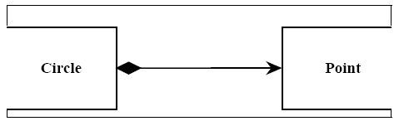

The black diamond represents composition. It is placed on the Circle class because it is the Circle that is composed of a Point. The arrowhead on the other end of the relationship denotes that the relationship is navigable in only one direction. That is, Point does not know about Circle. In UML relationships are presumed to be bidirectional unless the arrowhead is present to restrict them. Had I omitted the arrowhead, it would have meant that Point knew about Circle. At the code level, this would imply a #include “circle.h” within point.h. For this reason, I tend to use a lot of arrowheads.Composition relationships are a strong form of containment or aggregation. Aggregation is a whole/part relationship. In this case, Circle is the whole, and Point is part of Circle. How-ever, composition is more than just aggregation. Composition also indicates that the lifetime of Point is dependent upon Circle. This means that if Circle is destroyed, Point will be destroyed with it. For those of you who are familiar with the Booch-94 notation, this is the Has-by-value relationship.
In C++ we would represent this as shown in Listing 1.In this case we have represented the composition relationship as a member variable. We could also have used a pointer so long as the destructor of Circle deleted the pointer.

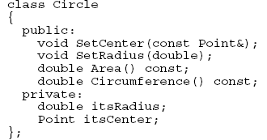

Inheritance Relationship
A peculiar triangular arrowhead depicts the inheritance relationship in UML. This arrowhead, that looks rather like a slice of pizza, points to the base class. One or more lines proceed from the base of the arrowhead connecting it to the derived classes. Figure shows the form of the inheritance relationship. In this diagram we see that Circle and
Square both derive from Shape. Note that the name of class Shape is shown in italics. This indicates that Shape is an abstract class. Note also that the operations, Draw () and Erase () are also shown in italics. This indicates that they are pure virtual.
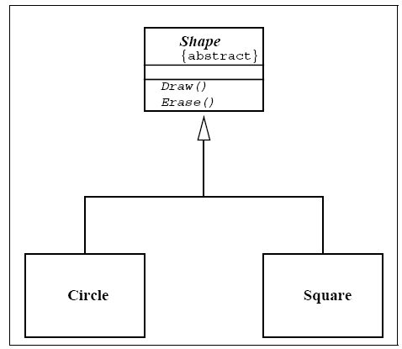

Italics are not always very easy to see. Therefore, as shown in Figure, an abstract class can also be marked with the {abstract} property. What’s more, though it is not a standard part of UML, I will often write Draw()=0 in the operations compartment to denote a pure virtual function.

Aggregation / Association
The weak form of aggregation is denoted with an open diamond. This relationship denotes that the aggregate class (the class with the white diamond touching it) is in some way the “whole”, and the other class in the relationship is somehow “part” of that whole.
Figure shows an aggregation relationship. In this case, the Window class contains many
Shape instances. In UML the ends of a relationship are referred to as its “roles”. Notice that the role at the Shape end of the aggregation is marked with a “ *”. This indicates that the Window contains many Shape instances. Notice also that the role has been named. This is the name that Window knows its Shape instances by. i.e. it is the name of the instance variable within Window that holds all the Shapes.

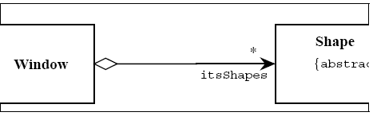

Above figure might be implemented in C++ code as under:

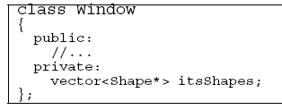

There are other forms of containment that do not have whole / part implications. For example, each window refers back to its parent Frame. This is not aggregation since it is not reasonable to consider a parent Frame to be part of a child Window. We use the association relationship to depict this.

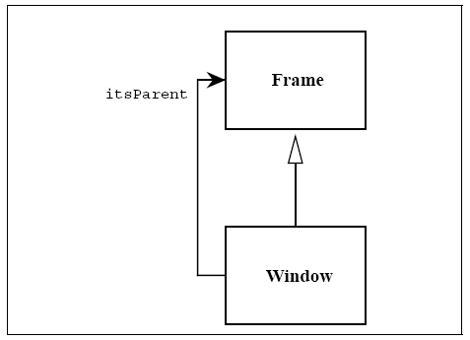

Figure shows how we draw an association. An association is nothing but a line drawn between the participating classes. In Figure 6 the association has an arrowhead to denote that Frame does not know anything about Window. Once again note the name on the role. This relationship will almost certainly be implemented with a pointer of some kind.
What is the difference between an aggregation and an association? The difference is one of implication. Aggregation denotes whole/part relationships whereas associations do not. However, there is not likely to be much difference in the way that the two relationships are implemented. That is, it would be very difficult to look at the code and determine whether a particular relationship ought to be aggregation or association. For this reason, it is pretty safe to ignore the aggregation relationship altogether. As the amigos said in the UML 0.8 document: “...if you don’t understand [aggregation] don’t use it.” Aggregation and Association both correspond to the Has-by-reference relationship from the Booch-94 notation.

Dependency
Sometimes the relationship between a two classes is very weak. They are not implemented with member variables at all. Rather they might be implemented as member function arguments. Consider, for example, the Draw function of the Shape class. Suppose that this function takes an argument of type Drawing Context.

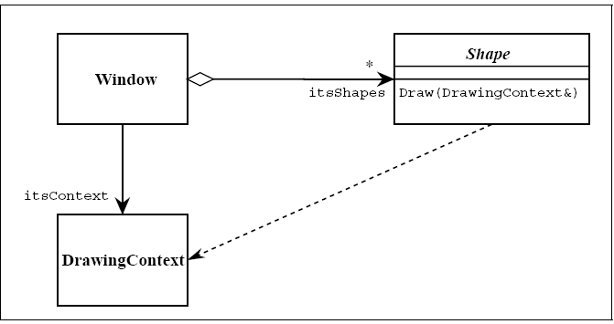

Figure shows a dashed arrow between the Shape class and the DrawingContext class. This is the dependency relationship. In Booch94 this was called a ‘using’ relationship. This relationship simply means that Shape somehow depends upon DrawingContext. In C++ this almost always results in a #include.

Interfaces
There are classes that have nothing but pure virtual functions. In Java such entities are not classes at all; they are a special language element called an interface. UML has followed the Java example and has created some special syntactic elements for such entities. The primary icon for an interface is just like a class except that it has a special denotation called a stereotype. Figure shows this icon. Note the «type» string at the top of the class. The two surrounding characters “«»” are called guillemots (pronounced Gee-may). A word or phrase surrounded by guillemots is called a “stereotype”. Stereotypes are one of the mechanisms that can be used to extend UML. When a stereotype is used above the name of a class it indicates that this class is a special kind of class that conforms to a rather rigid specification. The «type» stereotype indicates that the class is an interface. This means that it has no member variables, and that all of its member functions are pure virtual. UML supplies a shortcut for «type» classes. Figure 9 shows how the “lollypop” notation can be used to represent an interface. Notice that the dependency between Shape and DrawingContext is shown as usual. The class WindowsDC is derived from, or conforms to, the Drawingcontext interface. This is a shorthand notation for an inheritance relationship between

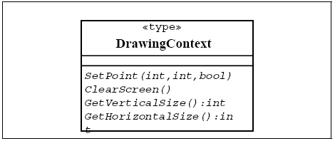

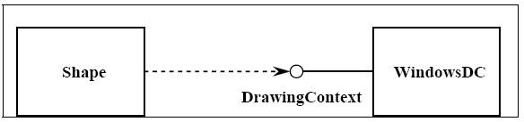

3.10. State chart diagram
For some operations, the behavior of the operation depends upon the state the receiver object is in. A state machine is a tool for describing the states the object can assume and the events that cause the object to move from one state to another. State machines are most useful for describing active classes. The use of state machines is particularly important for defining the behavior. An example of a simple state machine is shown below:

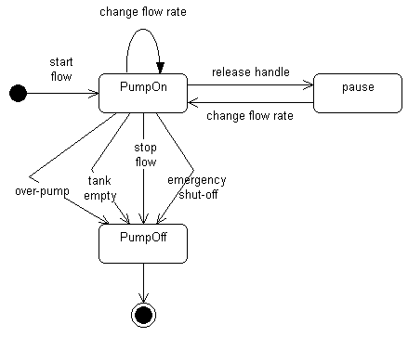

Each state transition event can be associated with an operation. Depending on the object's state, the operation may have a different behavior; the transition events describe how this occurs.
The method description for the associated operation should be updated with the state-specific information, indicating, for each relevant state, what the operation should do. States are often represented using attributes; the statechart diagrams serve as input into the attribute identification step.

3.11. Database Model
The data model is a subset of the implementation model, which describes the logical and physical representation of persistent data in the system.

The Relational Data Model
The relational model is composed of entities and relations. An entity may be a physical table or a logical projection of several tables also known as a view. The figure below illustrates LINEITEM and PRODUCT tables and the various relationships between them.
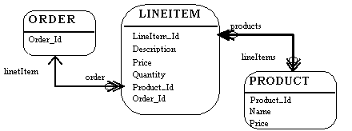

A relational model has the following elements:
An entity has columns. A name and a type identify each column. In the figure above, the LINEITEM entity has the columns LineItem_Id (the primary key), Description, Price, Quantity, Product_Id and Order_Id (the latter two are foreign keys that link the LINEITEM entity to the ORDER and PRODUCT entities).
An entity has records or rows. Each row represents a unique set of information, which typically represents an object's persistent data. Each entity has one or more primary keys. The primary keys uniquely identify each record (for example, Id is the primary key for LINEITEM table).
Support for relations is vendor specific. The example illustrates the logical model and the relation between the PRODUCT and LINEITEM tables. In the physical model relations are typically implemented using foreign key / primary key references. If one entity relates to another, it will contain columns, which are foreign keys. Foreign key columns contain data, which can relate specific records in the entity to the related entity.
Relations have multiplicity (also known as cardinality). Common cardinalities are one to one (1:1), one to many (1:m), many to one (m:1), and many to many (m:n). In the example, LINEITEM has a 1:1 relationship with PRODUCT and PRODUCT has a 0:m relationship with LINEITEM.

Example
A company has several departments. Each department has a supervisor and at least one employee. Employees must be assigned to at least one, but possibly more departments. At least one employee is assigned to a project, but an employee may be on vacation and not assigned to any projects. The important data fields are the names of the departments, projects, supervisors and employees, as well as the supervisor and employee number and a unique project number.
1. Identify Entities
The entities in this system are Department, Employee, Supervisor and Project. One is tempted to make Company an entity, but it is a false entity because it has only one instance in this problem. True entities must have more than one instance.
2. Find Relationships
We construct the following Entity Relationship Matrix:

 | Department | Employee | Supervisor | Project
Department |  | is assigned | run by
Employee | belongs to |  |  | works on
Supervisor | runs
Project |  | uses

3. Draw Rough ERD
We connect the entities whenever a relationship is shown in the entity Relationship Matrix.

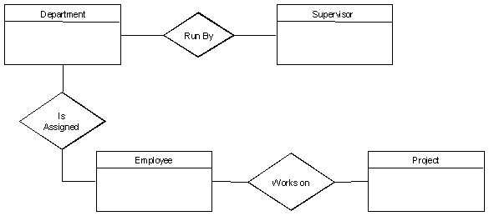

4. Fill in Cardinality
From the description of the problem we see that:
- Each department has exactly one supervisor.
- A supervisor is in charge of one and only one department.
- Each department is assigned at least one employee.
- Each employee works for at least one department.
- Each project has at least one employee working on it.
- An employee is assigned to 0 or more projects.

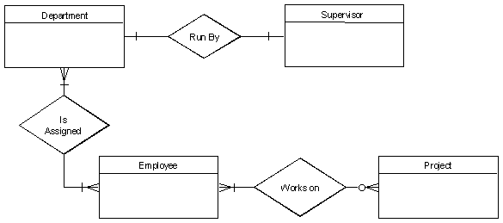

5. Define Primary Keys
The primary keys are Department Name, Supervisor Number, Employee Number, Project Number.

6. Draw Key-Based ERD
There are two many-to-many relationships in the rough ERD above, between Department and Employee and between Employee and Project. Thus we need the associative entities Department-Employee and Employee-Project. The primary key for Department-Employee is the concatenated key Department Name and Employee Number. The primary key for Employee-Project is the concatenated key Employee Number and Project Number.

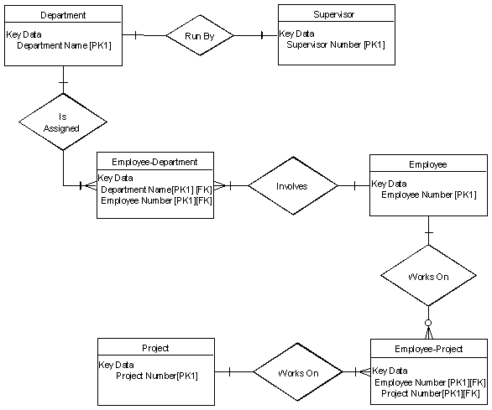
7. Identify Attributes
The only attributes indicated are the names of the departments, projects, supervisors and employees, as well as the supervisor and employee NUMBER and a unique project number.

8. Map Attributes

Attribute | Entity | Attribute | Entity
Department Name | Department | Supervisor Number | Supervisor
Employee Number | Employee | Supervisor Name | Supervisor
Employee Name | Employee | Project Name | Project
 |  | Project Number | Project
9. Draw Fully Attributed ERD
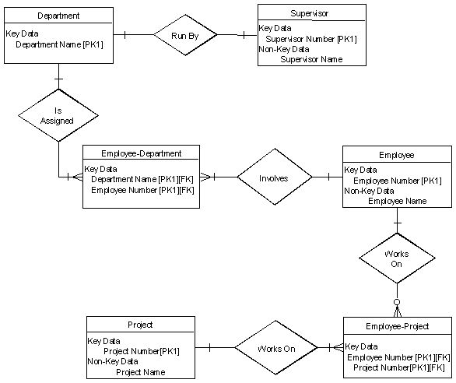

Chapter 4: User Interface Design

4.1. Introduction

A user interface design consists of three main parts:
Page elements should be visualized on paper before building them in the computer. Just as you draw a site map to plan the site, use cartoons and storyboards to begin blocking out the site’s appearance and navigational scheme.

- Site maps
- Storyboards
- Navigational maps
- Traceability Matrix

4.2. Site Maps
A site map's main benefit is to give users an overview of the site's areas in a single glance by dedicating an entire page to a visualization of the information architecture. If designed well, this overview can include several levels of hierarchy, and yet not be so big that users lose their ability to grasp the map as a whole. Some of the site maps we studied stretched over six screens on a standard 800x600 monitor. This is much too much. We recommend keeping the site map short; it should be no more than two-and-a-half times the window size most common among your users.
The greatest failures in our study came from site maps that attempted to lure the user into a dynamically twisting and expanding view, rather than presenting a simple, static representation of the information architecture. The site map's goal is to give users a single overview of the information space. If users have to work to reveal different parts of the map, that benefit is lost.
Dynamic site maps are basically an alternative way of navigating through the information space using a set of non-standard interaction techniques. For example, one site used a hyperbolic tree, where users had to click and drag clusters of links around the screen to expand areas of interest. Nobody could do this well.
A site map should not be a navigational challenge of its own. It should be a map.
As we have found again and again, users hated non-standard user interfaces that forced them to learn a special way of doing things for the sake of a single website. Site maps should be simple, compact layouts of links, and they should show everything in a single view.
If your site is large and complex, it is a good idea to include and index or site map that provides an outline of our site's content. This concept is something that we are all familiar with in the print world and it is very useful on the Web. An index is usually an alphabetical listing of key words that link to the appropriate pages in the site or it can be more like a table of contents. A site map is a graphical representation of the site's content. It doesn't usually have as much detailed information as the index has.
As web sites get more complicated, an index or site map is going to become more and more valuable and essential to the navigation of a good site.

4.3. Story boards
A storyboard is a sequence of single images, each of which represents a distinct event or narrative. It is also a visual representation of the script illustrating the interaction between the user and the machine. It can also be imagined as a film in visual-outline form.
A storyboard can be used in two ways. It describes the task, which are a series of images showing the user, environment and the machine. It also describes the interface, which represent series of screen images indicating the user’s representation and the computer’s response and work out interaction details when asking, “what happens next?” It also shows interaction sequence at a glance and helps develop usage scenarios to help develop tools & tasks.
All this can be done to construct a visual & verbal sequence that illustrates the interaction. Consider …

- Environment -- where system is used
- Visual cues -- what user can see
- Audible cues -- what user can hear
- Tactile cues -- what user can touch
- User input -- how the user communicates to the machine
- Machine output -- how the machine responds to the user
- User’s emotions -- how user perceives and responds to the interaction
- Technology -- what technology is involved in performing the task
- Quality of experience -- what benefit is perceived

HOW?
- Use a grid that puts the graphic representation above and the verbal description below
- Begin with loose thumbnail sketches and drawing for early design concepts. Refine with tighter drawings and screen designs for presentation and testing.
- Describe the interaction details and emotional responses verbally when no visual representation is effective
- Keep the medium loose and flexible in the conceptual design phase

These are the detailed screens, which pictorially represent the complete view of the screens. There would be symbols representing the different elements of the screens and in the end an index that would detail the symbols. Sample is given on the next page.

S1: Microsoft Products
S2: Username
S3: Password
T1:
T2:
B1: Submit
S1: static button 1
S2: static button 2
S3: static button 3
T1: text box 1
T2: text box 2
B1: button

4.4. Prototype
A prototype is an early sample, model, or release of a product built to test a concept or process. It is a term used in a variety of contexts, including semantics, design, electronics, and software programming. System analysts and users generally use a prototype to evaluate a new design to enhance precision. Prototyping serves to provide specifications for a real, working system rather than a theoretical one. In some design workflow models, creating a prototype (a process sometimes called materialization) is the step between the formalization and the evaluation of an idea.
A prototype can also mean a typical example of something such as in the use of the derivation 'prototypical'. This is a useful term in identifying objects, behaviors and concepts, which are considered the accepted norm.

4.5. Product Interfaces
The interface of the product is the “hardware” of it, i.e. it is with what the user interacts, can perceive and is tangible, and the interfaces are divided into:

Complex: when the product requires an explanation or prior knowledge specialized for its use, are usually accompanied by instructions.
Static: when the product does not have variety in its use itself.
Dynamic: when there are multiple uses in the product, such as a Smartphone for example, with this you can take photos, check social networks, make text documents, watch videos, etc.
User Interface: These are those that are focused on technology directly. It is the space where the user interacts with technology, such as operating systems, applications, web services, etc.

Having a good interface facilitates the interaction of the user with your products or services, it is the communication between them, think about how many times you have discarded products because when you use them you did not understand them well or because the interface seemed awful, likewise, think about your favorite products and you will realize that the communication and interaction you have with them is thanks to the interface makes it easier for you.
As an industrial designer I think it is very important to focus on making interfaces that facilitate the use of products to users especially when they are digital interfaces since, as a personal opinion, I believe that part of the functionality of the design is to humanize the technology for its use. After all the form we give to objects is only the structure that orders thought.

4.6. Navigational maps:
The next step is of navigational maps. In these maps, the storyboards are used as an input. The different display buttons or action buttons show the navigation from one screen to the other. In other words when one action button is pressed it would lead to other screens. This path and navigation would be shown.

4.7. Trace-ability Matrix

Following columns are involved in the trace-ability matrix.

Feature: Lists system features based on which use case are built.
Use Case ID: Write the ID of the use case for easy lookup.
UI ID: Write the user interface ID for this use case.
Priority: Give an appropriate rating to each use case according to its priority
Use Case Cross Ref: rite the related use cases separated with commas.
DB Table Id: write the relevant DB table ID’s
Elaborated Use-case ID: Elaboration of the related Use Cases separated by commas.
Dependent Classes: List of Classes separated by commas which are involved in achieving the Feature.

Chapter 5: Software Testing

5.1 Introduction:
This deliverable is based on the IEEE standard of software testing i.e. IEEE SOFTWARE TEST DOCUMENTATION Std 829-1998. This standard describes a set of basic test documents that are associated with the dynamic aspects of software testing (i.e., the execution of procedures and code). The standard defines the purpose, outline, and content of each basic document. While the documents described in the standard focus on dynamic testing, several of them may be applicable to other testing activities (e.g., the test plan and test incident report may be used for design and code reviews). This standard may be applied to commercial, scientific, or military software that runs on any digital computer. Applicability is not restricted by the size, complexity, or criticality of the software. However, the standard does not specify any class of software to which it must be applied. The standard addresses the documentation of both initial development testing and the testing of subsequent software releases. For a particular software release, it may be applied to all phases of testing from module testing through user acceptance. However, since all of the basic test documents may not be useful in each test phase, the particular documents to be used in a phase are not specified. Each organization using the standard will need to specify the classes of software to which it applies and the specific documents required for a particular test phase.

The standard does not call for specific testing methodologies, approaches, techniques, facilities, or tools, and does not specify the documentation of their use. Additional test documentation may be required (e.g., code inspection checklists and reports). The standard also does not imply or impose specific methodologies for documentation control, configuration management, or quality assurance. Additional documentation (e.g., a quality assurance plan) may be needed depending on the particular methodologies used.

Following are standard artifacts, which must be included in this deliverable:
- Test Plan
- Test Design Specification
- Test Case Specification
- Test Procedure Specification
- Test Item Transmittal Report
- Test Log
- Test Incident Report
- Test Summary Report

5.2. Black box plan/White box plan/Grey box plan

5.2.1. Black Box Testing
Black Box Testing is a software testing method in which the functionalities of software applications are tested without having knowledge of internal code structure, implementation details and internal paths. Black Box Testing mainly focuses on input and output of software applications and it is entirely based on software requirements and specifications. It is also known as Behavioral Testing.
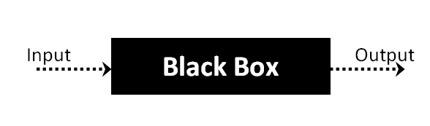
The above Black Box can be any software system you want to test. For Example, an operating system like Windows, a website like Google, a database like Oracle or even your own custom application. Under Black Box Testing, you can test these applications by just focusing on the inputs and outputs without knowing their internal code implementation.

5.2.1.1. Types of Black Box Testing
There are many types of Black Box Testing but the following are the prominent ones –
Functional testing
This black box testing type is related to the functional requirements of a system; software testers do it.
Non-functional testing
This type of black box testing is not related to testing of specific functionality, but non-functional requirements such as performance, scalability, usability.
Regression testing
Regression Testing is done after code fixes, upgrades or any other system maintenance to check the new code has not affected the existing code.

5.2.1.2. Tools used for Black Box Testing:
Tools used for Black box testing largely depends on the type of black box testing you are doing.
For Functional/ Regression Tests you can use – QTP, Selenium
For Non-Functional Tests, you can use – LoadRunner, Jmeter.

5.2.2. White Box Testing
White Box Testing is software-testing technique in which internal structure, design and coding of software are tested to verify flow of input-output and to improve design, usability and security. In white box testing, code is visible to testers so it is also called Clear box testing, Open box testing, Transparent box testing, Code-based testing and Glass box testing.
It is one of two parts of the Box Testing approach to software testing. Its counterpart, Black box testing, involves testing from an external or end-user type perspective. On the other hand, White box testing in software engineering is based on the inner workings of an application and revolves around internal testing.
The term “White Box” was used because of the see-through box concept. The clear box or White Box name symbolizes the ability to see through the software’s outer shell (or “box”) into its inner workings. Likewise, the “black box” in “Black Box Testing” symbolizes not being able to see the inner workings of the software so that only the end-user experience can be tested.

5.2.2.1. Types of White Box Testing
White box testing encompasses several testing types used to evaluate the usability of an application, block of code or specific software package. There are listed below —
Unit Testing
It is often the first type of testing done on an application. Unit Testing is performed on each unit or block of code as it is developed. Unit the programmer essentially does Testing. As a software developer, you develop a few lines of code, a single function or an object and test it to make sure it works before continuing Unit Testing helps identify a majority of bugs, early in the software development lifecycle. Bugs identified in this stage are cheaper and easy to fix.
Testing for Memory Leaks
Memory leaks are leading causes of slower running applications. A QA specialist who is experienced at detecting memory leaks is essential in cases where you have a slow running software application.

5.2.2.2. White Box Testing Tools
Below is a list of top white box testing tools.
Parasoft Jtest
EclEmma
NUnit
PyUnit
HTMLUnit
CppUnit

5.2.3. Grey Box Testing
Grey Box Testing or Gray box testing is a software testing technique to test a software product or application with partial knowledge of internal structure of the application. The purpose of grey box testing is to search and identify the defects due to improper code structure or improper use of applications.
In this process, context-specific errors that are related to web systems are commonly identified. It increases the testing coverage by concentrating on all of the layers of any complex system.
Gray Box Testing is a software testing method, which is a combination of both White Box Testing and Black Box Testing method.
- In White Box testing internal structure (code) is known
- In Black Box testing internal structure (code) is unknown
- In Grey Box Testing internal structure (code) is partially known
In Software Engineering, Gray Box Testing gives the ability to test both sides of an application, presentation layer as well as the code part. It is primarily useful in Integration Testing and Penetration Testing.

5.2.3.1. Techniques used for Grey box Testing
- Matrix Testing: This testing technique involves defining all the variables that exist in their programs.
- Regression Testing: To check whether the change in the previous version has regressed other aspects of the program in the new version. It will be done by testing strategies like retest all, retest risky use cases, retest within a firewall.
- Orthogonal Array Testing or OAT: It provides maximum code coverage with minimum test cases.
- Pattern Testing: This testing is performed on the historical data of the previous system defects. Unlike black box testing, gray box testing digs within the code and determines why the failure happened

5.3. Test plan

5.3.1. Purpose
To prescribe the scope, approach, resources, and schedule of the testing activities. To identify the items being tested, the features to be tested, the testing tasks to be performed, the personnel responsible for each task, and the risks associated with this plan.

5.3.2. Outline
A test plan shall have the following structure:

- Test plan identifier
- Introduction
- Test items
- Features to be tested
- Features not to be tested
- Approach
- Item pass/fail criteria
- Suspension criteria and resumption requirements
- Test deliverables
- Testing tasks
- Environmental needs
- Responsibilities
- Staffing and training needs
- Schedule
- Risks and contingencies
- Approvals

The sections shall be ordered in the specified sequence. Additional sections may be included immediately prior to Approvals. If some or all of the content of a section is in another document, then a reference to that material may be listed in place of the corresponding content. The referenced material must be attached to the test plan or available to users of the plan.
Details on the content of each section are contained in the following sub-clauses.

5.2.2.1. Test plan identifier
Specify the unique identifier assigned to this test plan.

5.2.2.2. Introduction
Summarize the software items and software features to be tested. The need for each item and its history may be included. References to the following documents, when they exist, are required in the highest-level test plan:

- Project authorization;
- Project plan;
- Quality assurance plan;
- Configuration management plan;
- Relevant policies;
- Relevant standards.

In multilevel test plans, each lower-level plan must reference the next higher-level plan.

5.2.2.3. Test items
Identify the test items including their version/revision level. Also specify characteristics of their transmittal media that impact hardware requirements or indicate the need for logical or physical transformations before testing can begin (e.g., programs must be transferred from tape to disk).
Supply references to the following test item documentation, if it exists:

a) Requirements specification
b) Design specification
c) Users guide
d) Operations guide
e) Installation guide
Reference any incident reports relating to the test items. Items that are to be specifically excluded from testing may be identified.

5.2.2.4. Features to be tested
Identify all software features and combinations of software features to be tested. Identify the test design specification associated with each feature and each combination of features.

5.2.2.5. Features not to be tested
Identify all features and significant combinations of features that will not be tested and the reasons.

5.2.2.6. Approach
Describe the overall approach to testing. For each major group of features or feature combinations, specify the approach that will ensure that these feature groups are adequately tested. Specify the major activities, techniques, and tools that are used to test the designated groups of features.
The approach should be described in sufficient detail to permit identification of the major testing tasks and estimation of the time required to do each one.
Specify the minimum degree of comprehensiveness desired. Identify the techniques that will be used to judge the comprehensiveness of the testing effort (e.g., determining which statements have been executed at least once). Specify any additional completion criteria (e.g., error frequency). The techniques to be used to trace requirements should be specified. Identify significant constraints on testing such as test item availability, testing resource availability, and deadlines.

5.2.2.7. Item pass/fail criteria
Specify the criteria to be used to determine whether each test item has passed or failed testing.

5.2.2.8. Suspension criteria and resumption requirements
Specify the criteria used to suspend all or a portion of the testing activity on the test items associated with this plan. Specify the testing activities that must be repeated, when testing is resumed.

5.2.2.9. Test deliverables
Identify the deliverable documents. The following documents should be included:
- Test plan;
- Test design specifications;
- Test case specifications;
- Test procedure specifications;
- Test item transmittal reports;
- Test logs;
- Test incident reports;
- Test summary reports.
Test input data and test output data should be identified as deliverables.
Test tools (e.g., module drivers and stubs) may also be included.

5.2.2.10. Testing tasks
Identify the set of tasks necessary to prepare for and perform testing. Identify all inter task dependencies and any special skills required.

5.2.2.11. Environmental needs
Specify both the necessary and desired properties of the test environment. This specification should contain the physical characteristics of the facilities including the hardware, the communications and system software, the mode of usage (e.g., stand-alone), and any other software or supplies needed to support the test. Also specify the level of security that must be provided for the test facilities, system software, and proprietary components such as software, data, and hardware. Identify special test tools needed.
Identify any other testing needs (e.g., publications or office space). Identify the source for all needs that are not currently available to the test group.

5.2.2.12. Responsibilities
Identify the groups responsible for managing, designing, preparing, executing, witnessing, checking, and resolving. In addition, identify the groups responsible for providing the test items identified in 7.2.2.3 and the environmental needs identified in 5.2.2.11.
These groups may include the developers, testers, operations staff, user representatives, technical support staff, data administration staff, and quality support staff.

5.2.2.13 Staffing and training needs
Specify test-staffing needs by skill level. Identify training options for providing necessary skills.

5.2.2.14. Schedule
Include test milestones identified in the software project schedule as well as all item transmittal events.
Define any additional test milestones needed. Estimate the time required to do each testing task. Specify the schedule for each testing task and test milestone. For each testing resource (i.e., facilities, tools, and staff), specify its periods of use.

5.2.2.15. Risks and contingencies
Identify the high-risk assumptions of the test plan. Specify contingency plans for each (e.g., delayed delivery of test items might require increased night shift scheduling to meet the delivery date).

5.2.2.16 Approvals
Specify the names and titles of all persons who must approve this plan. Provide space for the signatures and dates.

5.4. Test design specification

5.4.1. Purpose
To prescribe the scope, approach, resources, and schedule of the testing activities. To identify the items being tested, the features to be tested, the testing tasks to be performed, the personnel responsible for each task, and the risks associated with this plan.

5.4.2. Outline
A test plan shall have the following structure:

- Test plan identifier;
- Introduction;
- Test items;
- Features to be tested;
- Features not to be tested;
- Approach;
- Item pass/fail criteria;
- Suspension criteria and resumption requirements;
- Test deliverables;
- Testing tasks;
- Environmental needs;
- Responsibilities;
- Staffing and training needs;
- Schedule;
- Risks and contingencies;
- Approvals.

The sections shall be ordered in the specified sequence. Additional sections may be included immediately prior to Approvals. If some or all of the content of a section is in another document, then a reference to that material may be listed in place of the corresponding content. The referenced material must be attached to the test plan or available to users of the plan.
Details on the content of each section are contained in the following sub-clauses.

5.4.2.1 Test plan identifier
Specify the unique identifier assigned to this test plan.

5.4.2.2. Introduction
Summarize the software items and software features to be tested. The need for each item and its history may be included. References to the following documents, when they exist, are required in the highest-level test plan:

- Project authorization
- Project plan
- Quality assurance plan
- Configuration management plan
- Relevant policies
- Relevant standards

In multilevel test plans, each lower-level plan must reference the next higher-level plan.

5.4.2.3. Test items
Identify the test items including their version/revision level. Also specify characteristics of their transmittal media that impact hardware requirements or indicate the need for logical or physical transformations before testing can begin (e.g., programs must be transferred from tape to disk). Supply references to the following test item documentation, if it exists:

- Requirements specification
- Design specification
- Users guide
- Operations guide
- Installation guide

Reference any incident reports relating to the test items. Items that are to be specifically excluded from testing may be identified.

5.4.2.4. Features to be tested
Identify all software features and combinations of software features to be tested. Identify the test design specification associated with each feature and each combination of features.

5.4.2.5. Features not to be tested
Identify all features and significant combinations of features that will not be tested and the reasons.

5.4.2.6. Approach
Describe the overall approach to testing. For each major group of features or feature combinations, specify the approach that will ensure that these feature groups are adequately tested. Specify the major activities, techniques, and tools that are used to test the designated groups of features.
The approach should be described in sufficient detail to permit identification of the major testing tasks and estimation of the time required to do each one. Specify the minimum degree of comprehensiveness desired. Identify the techniques that will be used to judge the comprehensiveness of the testing effort (e.g., determining which statements have been executed at least once).
Specify any additional completion criteria (e.g., error frequency). The techniques to be used to trace requirements should be specified. Identify significant constraints on testing such as test item availability, testing resource availability, and deadlines.

5.4.2.7. Item pass/fail criteria
Specify the criteria to be used to determine whether each test item has passed or failed testing.

5.4.2.8. Suspension criteria and resumption requirements
Specify the criteria used to suspend all or a portion of the testing activity on the test items associated with this plan. Specify the testing activities that must be repeated, when testing is resumed.

5.4.2.9. Test deliverables
Identify the deliverable documents. The following documents should be included:
- Test plan
- Test design specifications
- Test case specifications
- Test procedure specifications
- Test item transmittal reports
- Test logs
- Test incident reports
- Test summary reports

Test input data and test output data should be identiÞed as deliverables. Test tools (e.g., module drivers and stubs) may also be included.

5.4.2.10. Testing tasks
Identify the set of tasks necessary to prepare for and perform testing. Identify all inter task dependencies and any special skills required.

5.4.2.11. Environmental needs
Specify both the necessary and desired properties of the test environment. This specification should contain the physical characteristics of the facilities including the hardware, the communications and system software, the mode of usage (e.g., stand-alone), and any other software or supplies needed to support the test. Also specify the level of security that must be provided for the test facilities, system software, and proprietary components such as software, data, and hardware. Identify special test tools needed.
Identify any other testing needs (e.g., publications or office space). Identify the source for all needs that are not currently available to the test group.

5.4.2.12. Responsibilities
Identify the groups responsible for managing, designing, preparing, executing, witnessing, checking, and resolving. In addition, identify the groups responsible for providing the test items identified in 7.2.2.3 and the environmental needs identified in these groups may include the developers, testers, operations staff, user representatives, technical support staff, data administration staff, and quality support staff.

5.4.2.13. Staffing and training needs
Specify test-staffing needs by skill level. Identify training options for providing necessary skills.

5.4.2.14. Schedule
Include test milestones identified in the software project schedule as well as all item transmittal events. Define any additional test milestones needed. Estimate the time required to do each testing task. Specify the schedule for each testing task and test milestone. For each testing resource (i.e., facilities, tools, and staff), specify its periods of use.

5.4.2.15. Risks and contingencies
Identify the high-risk assumptions of the test plan. Specify contingency plans for each (e.g., delayed delivery of test items might require increased night shift scheduling to meet the delivery date)

5.4.2.16. Approvals
Specify the names and titles of all persons who must approve this plan. Provide space for the signatures and dates.

5.5. Test Case Specification

5.5.1. Purpose
To define a test case identified by a test design specification.

5.5.2. Outline
A test case specification shall have the following structure:

- Test case specification identifier
- Test items
- Input specifications
- Output specifications
- Environmental needs
- Special procedural requirements
- Inter case dependencies

The sections shall be ordered in the specified sequence. Additional sections may be included at the end. If some or all of the content of a section is in another document, then a reference to that material may be listed in place of the corresponding content. The referenced material must be attached to the test case specification or available to users of the case specification. Since a test case may be referenced by several test design specifications used by different groups over a long time period, enough specific information must be included in the test case specification to permit reuse.
Details on the content of each section are contained in the following sub-clauses.

5.5.2.1. Test case specification identifier
Specify the unique identifier assigned to this test case specification.

5.5.2.2 Test items
Identify and briefly describe the items and features to be exercised by this test case.
For each item, consider supplying references to the following test item documentation:
- Requirements specification
- Design specification
- Users guide
- Operations guide
- Installation guide

5.5.2.3. Input specifications
Specify each input required to execute the test case. Some of the inputs will be specified by value (with tolerances where appropriate), while others, such as constant tables or transaction files, will be specified by name. Identify all appropriate databases, files, terminal messages, memory resident areas, and values passed by the operating system.
Specify all required relationships between inputs (e.g., timing).

5.5.2.4. Output specifications
Specify all of the outputs and features (e.g., response time) required of the test items. Provide the exact value (with tolerances where appropriate) for each required output or feature.

5.5.2.5. Environmental needs

5.5.2.5.1. Hardware
Specify the characteristics and configurations of the hardware required to execute this test case (e.g., 132 character´ 24 line CRT).

5.5.2.5.2. Software
Specify the system and application software required to execute this test case. This may include system software such as operating systems, compilers, simulators, and test tools. In addition, the test item may interact with application software.

5.5.2.5.3. Other
Specify any other requirements such as unique facility needs or specially trained personnel.

5.5.2.6. Special procedural requirements
Describe any special constraints on the test procedures that execute this test case. These constraints may involve special set up, operator intervention, output determination procedures, and special wrap up.

5.5.2.7. Inter case dependencies
List the identifiers of test cases that must be executed prior to this test case. Summarize the nature of the dependencies.

5.6. Test procedure specification

5.6.1. Purpose
To specify the steps for executing a set of test cases or, more generally, the steps used to analyze a software item in order to evaluate a set of features.

5.6.2 Outline
A test procedure specification shall have the following structure:

- Test procedure specification identifier
- Purpose
- Special requirements
- Procedure steps

The sections shall be ordered in the specified sequence. Additional sections, if required, may be included at the end. If some or all of the content of a section is in another document, then a reference to that material may be listed in place of the corresponding content. The referenced material must be attached to the test procedure specification or available to users of the procedure specification.
Details on the content of each section are contained in the following sub clauses.

5.6.2.1. Test procedure specification identifier
Specify the unique identifier assigned to this test procedure specification. Supply a reference to the associated test design specification.

5.6.2.2. Purpose
Describe the purpose of this procedure. If this procedure executes any test cases, provide a reference for each of them. In addition, provide references to relevant sections of the test item documentation (e.g., references to usage procedures).

5.6.2.3. Special requirements
Identify any special requirements that are necessary for the execution of this procedure. These may include prerequisite procedures, special skills requirements, and special environmental requirements.

5.6.2.4. Procedure steps
Include the steps in 8.5.2.4.1. through 8.5.2.4.10 as applicable.

5.6.2.4.1. Log
Describe any special methods or formats for logging the results of test execution, the incidents observed, and any other events pertinent to the test (see Clauses 9 and 10).

5.6.2.4.2. Set up
Describe the sequence of actions necessary to prepare for execution of the procedure.

5.6.2.4.3. Start
Describe the actions necessary to begin execution of the procedure.

5.6.2.4.4. Proceed
Describe any actions necessary during execution of the procedure.

5.6.2.4.5. Measure
Describe how the test measurements will be made (e.g., describe how remote terminal response time is to be measured using a network simulator).

5.6.2.4.6. Shut down
Describe the actions necessary to suspend testing, when unscheduled events dictate.

5.6.2.4.7. Restart
Identify any procedural restart points and describe the actions necessary to restart the procedure at each of these points.

5.6.2.4.8. Stop
Describe the actions necessary to bring execution to an orderly halt.

5.6.2.4.9. Wrap up
Describe the actions necessary to restore the environment.

5.6.2.4..10. Contingencies
Describe the actions necessary to deal with anomalous events that may occur during execution.

5.7. Test item transmittal report

5.7.1. Purpose
To identify the test items being transmitted for testing. It includes the person responsible for each item, its physical location, and its status. Any variations from the current item requirements and designs are noted in this report.

5.7.2. Outline
A test item transmittal report shall have the following structure:

- Transmittal report identifier
- Transmitted items
- Location
- Status
- Approvals

The sections shall be ordered in the specified sequence. Additional sections may be included just prior to Approvals. If some or all of the content of a section is in another document, then a reference to that material may be listed in place of the corresponding content. The referenced material must be attached to the test item transmittal report or available to users of the transmittal report.
Details on the content of each section are contained in the following sub clauses.

5.7.2.1. Transmittal report identifier
Specify the unique identifier assigned to this test item transmittal report.

5.7.2.2. Transmitted items
Identify the test items being transmitted, including their version/revision level. Supply references to the item documentation and the test plan relating to the transmitted items. Indicate the people responsible for the transmitted items.

5.7.2.3. Location
Identify the location of the transmitted items. Identify the media that contain the items being transmitted. When appropriate, indicate how specific media are labeled or identified.

5.7.2.4. Status
Describe the status of the test items being transmitted. Include deviations from the item documentation, from previous transmittals of these items, and from the test plan. List the incident reports that are expected to be resolved by the transmitted items. Indicate if there are pending modifications to item documentation that may affect the items listed in this transmittal report.

5.7.2.5. Approvals
Specify the names and titles of all persons who most approve this transmittal. Provide space for the signatures and dates.

5.8. Test log

5.8.1. Purpose
To provide a chronological record of relevant details about the execution of tests.

5.8.2. Outline
A test log shall have the following structure:
- Test log identifier;
- Description;
- Activity and event entries.

The sections shall be ordered in the specified sequence. Additional sections may be included at the end. If some or all of the content of a section is in another document, then a reference to that material may be listed in place of the corresponding content. The referenced material must be attached to the test log or available to users of the log. Details on the content of each section are contained in the following sub clauses.

5.8.2.1. Test log identifier
Specify the unique identifier assigned to this test log.

5.8.2.2. Description
Information that applies to all entries in the log except as specifically noted in a log entry should be included here. The following information should be considered:
- Identify the items being tested including their version/revision levels. For each of these items, supply a reference to its transmittal report, if it exists.
- Identify the attributes of the environments in which the testing is conducted. Include facility identification, hardware being used (e.g., amount of memory being used, CPU model number, and number and model of tape drives, and/or mass storage devices), system software used, and resources available (e.g., the amount of memory available).

5.8.2.3. Activity and event entries
For each event, including the beginning and end of activities, record the occurrence date and time along with the identity of the author. The information in 9.2.3.1 through 9.2.3.5 should be considered:

5.8.2.3.1. Execution description
Record the identifier of the test procedure being executed and supply a reference to its specification. Record all personnel present during the execution including testers, operators, and observers. Also indicate the function of each individual.

5.8.2.3.2. Procedure results
For each execution, record the visually observable results (e.g., error messages generated, aborts, and requests for operator action). Also record the location of any output (e.g., reel number). Record the successful or unsuccessful execution of the test.

5.8.2.3.3. Environmental information
Record any environmental conditions specific to this entry (e.g., hardware substitutions).

5.8.2.3.4. Anomalous events
Record what happened before and after an unexpected event occurred (e.g., A summary display was requested and the correct screen displayed, but response seemed unusually long. A repetition produced the same prolonged response). Record circumstances surrounding the inability to begin execution of a test procedure or failure to complete a test procedure (e.g., a power failure or system software problem).

5.8.2.3.5. Incident report identifiers
Record the identifier of each test incident report, whenever one is generated.

5.9. Test incident report

5.9.1. Purpose
To document any event that occurs during the testing process that requires investigation.

5.9.2. Outline
A test incident report shall have the following structure:

- Test incident report identifier
- Summary
- Incident description
- Impact

The sections shall be ordered in the specified sequence. Additional sections may be included at the end. If some or all of the content of a section is in another document, then a reference to that material may be listed in place of the corresponding content. The referenced material must be attached to the test incident report or available to users of the incident report.
Details on the content of each section are contained in the following sub clauses.

5.9.2.1. Test incident report identifier
Specify the unique identifier assigned to this test incident report.

5.9.2.2. Summary
Summarize the incident. Identify the test items involved indicating their version/revision level. References to
the appropriate test procedure specification, test case specification, and test log should be supplied.

5.9.2.3. Incident description
Provide a description of the incident. This description should include the following items:
- Inputs
- Expected results
- Actual results
- Anomalies
- Date and time;
- Procedure step;
- Environment;
- Attempts to repeat;
- Testers;
- Observers.

Related activities and observations that may help to isolate and correct the cause of the incident should be included (e.g., describe any test case executions that might have a bearing on this particular incident and any variations from the published test procedure).

5.9.2.4. Impact
If known, indicate what impact this incident will have on test plans, test design specifications, test procedure specifications, or test case specifications.

5.10. Test summary report

5.10.1. Purpose
To summarize the results of the designated testing activities and to provide evaluations based on these results.

5.10.2. Outline
A test summary report shall have the following structure:
- Test summary report identifier
- Summary
- Variances
- Comprehensive assessment
- Summary of results
- Evaluation
- Summary of activities
- Approvals

The sections shall be ordered in the specified sequence. Additional sections may be included just prior to Approvals. If some or all of the content of a section is in another document, then a reference to that material may be listed in place of the corresponding content. The referenced material must be attached to the test summary report or available to users of the summary report.
Details on the content of each section are contained in the following sub clauses.

5.10.2.1. Test summary report identifier
Specify the unique identifier assigned to this test summary report.

5.10.2.2. Summary
Summarize the evaluation of the test items. Identify the items tested, indicating their version/revision level. Indicate the environment in which the testing activities took place.
For each test item, supply references to the following documents if they exist: test plan, test design specifications, test procedure specifications, test item transmittal reports, test logs, and test incident reports.

5.10.2.3. Variances
Report any variances of the test items from their design specifications. Indicate any variances from the test plan, test designs, or test procedures. Specify the reason for each variance.

5.10.2.4. Comprehensiveness assessment
Evaluate the comprehensiveness of the testing process against the comprehensiveness criteria specified in the test plan if the plan exists. Identify features or feature combinations that were not sufficiently tested and explain the reasons.

5.10.2.5. Summary of results
Summarize the results of testing. Identify all resolved incidents and summarize their resolutions. Identify all unresolved incidents.

5.10.2.6. Evaluation
Provide an overall evaluation of each test item including its limitations. This evaluation shall be based upon the test results and the item level pass/fail criteria. An estimate of failure risk may be included.

5.10.2.7. Summary of activities
Summarize the major testing activities and events. Summarize resource consumption data, e.g., total staffing level, total machine time, and total elapsed time used for each of the major testing activities.

5.10.2.8. Approvals
Specify the names and titles of all persons who must approve this report. Provide space for the signatures and dates.

Chapter 6: Conclusion And Future Work

Appendixes:

Appendix 1: Final Documentation Format Guidelines
Typographical Format and Binding
Page Format:

Page size: A4
Top margin: 1.00 inch
Bottom margin: 1.00 inch
Left margin: 1.25 inch
Right margin: 1.00 inch

Page numbering: Bottom right - part of the footnote
Title page not numbered
All other pages before the page of chapter one numbered in lower roman numerals (i, ii, iii, …)
All other pages starting from first page of chapter one to last page of the report numbered in integers (1, 2, 3, …)

Footer: Each page shall have a footnote “Division of Science & Technology, University of Education, Lahore”
Left aligned
In case of long titles shorter versions should be used.
There shall be a line over the footnote.

Header: Each page shall have a header “Project Name”
Left aligned
In case of long titles shorter versions should be used.
There shall be a line under the footnote.

Chapter Startup: Each chapter shall be numbered as Chapter 1, Chapter 2, etc. The name of the chapter shall be written immediately below. Both shall be centered horizontally as well as vertically.
The actual chapter content shall start from the next page.7

Text: Only one side of the paper shall be used.
The other side shall be blank.
When a report is opened the right side would contain text, figures, or tables and the left side would be blank.

Tables and Figures: Tables and figures shall be placed on one side only
Separate pages shall be used for figures and tables.
One page may contain more than one figure or table but text will not be combined or interlaced with figure or table.
Each table / figure shall be numbered.
For example "Table 1.2: Population distribution in Asia" or "Figure 3.2: Temperature distribution"
The table number or figure number shall be placed as normal text centered at the bottom of the table or figure or sideways with table / figure title coming on the opening side of the paper and note on the binding side.

Paragraph:

Single-spaced.
Line entered paragraph.
DONOT put indents at the beginning of the paragraph.
Left aligned or justified.

Text Format

Normal and plane text:
Font Type: Times New Roman
Font Size: 12
Headings:
Chapter Heading: Times New Roman Bold Size 16 Title Case normal
Heading 1: Times New Roman Bold Size 14 Title Case normal
Heading 2: Times New Roman Bold Size 12 Title Case normal
Heading 3: Times New Roman Bold Size 12 Title Case italic

Sections and Subsections

In case of sections and subsections follow this format:

1 Section
1.1 Sub Section
1.1.1 Nested Sub Section
a
b
i
ii

The subsequent reference to a any section shall be made using the section and its number. For example section 2.1.3 means chapter 2 section 1 subsection 3.

Mathematical Equations

The following numbering scheme should be used to number the equations:
f(x) = x+3 (XX:YY)
Where XX is the chapter number and YY is the sequence number of that equation in that chapter.
If an equation is previously quoted in an earlier chapter, say as equation 4:5 and need to be re-quoted in chapter 5, its number will remain as equation 4:5.

References

References are to be placed in square brackets and interlaced in the text. For example "A comprehensive detail of how to prevent accidents and losses caused by technology can be found in the literature [1]. A project report / thesis cannot be accepted without proper references. The references shall be quoted in the following format:

The articles from journals, books, and magazines are written as:
[1] Abe, M., S. Nakamura, K. Shikano, and H. Kuwabara. Voice conversion through vector quantization. Journal of the Acoustical Society of Japan, April 1990, E-11 pp 71-76.
[2] Hermansky, H. Perceptual linear predictive (PLP) analysis for speech. Journal of the Acoustical Society of America, January 1990, pp 1738-1752.
The books are written as:
[1] Nancy G. Leveson, Safeware System Safety and Computers, A guide to preventing accidents and losses caused by technology, Addison-Wesley Publishing Company, Inc. America, 1995.
[2] Richard R. Brooks, S. S. Iyengar, Multi-Sensor Fusion Fundamentals and Applications with Software, The Prentice-Hall Inc. London, 1998.

Binding

All reports shall be bounded with an appropriate print on the backbone.
Two copies should be submitted.

Color of the binding:
- BSc project / thesis reports: black
- MSc project / thesis reports: blue

Contents of the CD Attached
All reports / theses must accompany a CD whose contents will have the following:

Top-level directories:
Doc All documents related to the project
Instructions how to access the CD to the point to running the project
All reports already submitted
The final project report in thesis form
Installation instructions
Trouble shooting instructions in case of problems
User manual
Research material including URLs
Papers consulted / referred to
Slides of the presentations
Source All source files that will be needed to compile the project.
Further subdirectories can be used.
This must include sample data files as well.
Project The running project including sample data files as well as sample output.
This should be in a form that if copied to a machine runs without errors.
This may an exe file of an entire project, an installer depending on the project or simply a running project.
You can have sub directories with appropriate names.

Length
The length of your dissertation depends on the type of project you have selected. An excellent dissertation will often be brief but effective (its author will have said a lot in a small amount of space). Voluminous data can be submitted electronically on CD.

